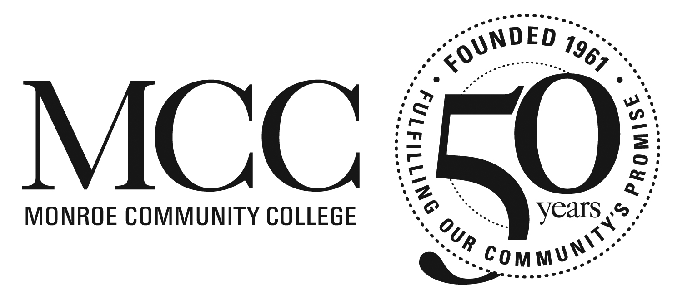

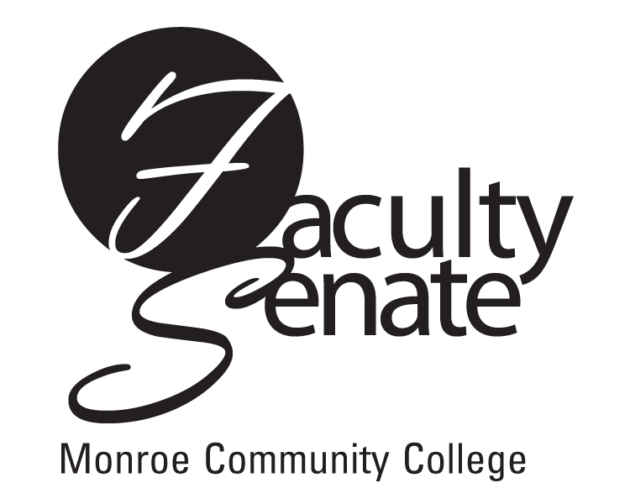
Faculty Senate Meeting Agenda
November 15, 2012 at 3:30 p.m.
Empire Room - Warshrof Conference Center

1. Guest Speakers: M. McDonough & C. Downing – Curriculum Update

2. Announcements

3. Student Announcements

4. Approval of Minutes from October 18, 2012 Faculty Senate Meeting

5. Action Items:
a. Suspension of Student Opinions of Courses & Faculty for Fall Semester
b. Faculty Senate Resolution – Rights & Responsibilities
c. Faculty Council of Community Colleges Resolution Supporting “Rational Revenue Plan” for the Community Colleges - FCCC Resolution #G1 2012-13

6. Standing Committee Reports

7. Old Business

8. New Business

