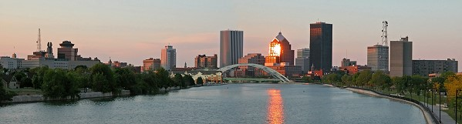
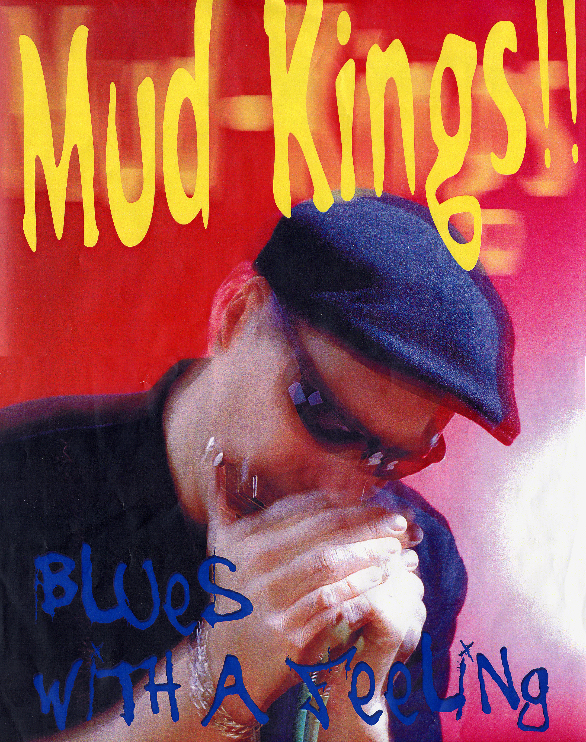
live blues!
MCC Faculty Association
After Graduation Party

Tuesday
5 June 2007
9:30 – midnight

Welcome faculty, staff,
& administrators!
(No students, please)

Live music, appetizers & cash bar

Stock exchange restaurant
120 First Federal Plaza
(Directions/Map on back)

The Stock Exchange Restaurant is less
than a 1/4 mile from Blue Cross Arena!
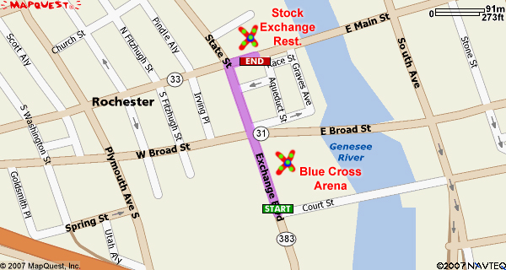
Directions from the Blue Cross Arena!
- Head north on Exchange Blvd.
- Turn right on Main Street.
- Once reaching 120 First Federal Plaza, take walkway right of the Plaza main entrance along the river into the Stock Exchange Restaurant.
.

For more info on downtown parking, visit:
- http://rochesterdowntown.com/downloads/rochester-parkingmap.pdf

