

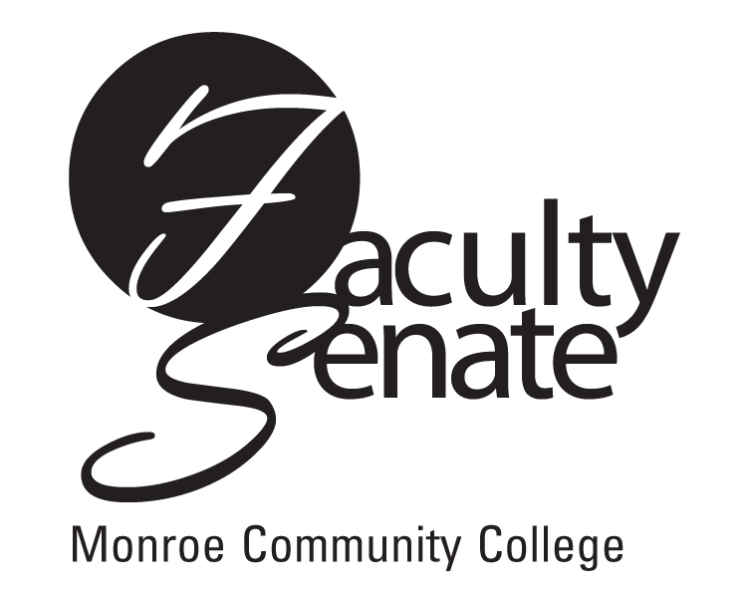
Faculty Senate Agenda
Warshof Conference Center
Empire Room
November 15, 2007
3:30 p.m.

- Guest Speaker: Dale Mallory – New College-wide Password Policy

2. Announcements

3. Approval of Minutes from October Faculty Senate Meeting

4. Action Items:
Academic Policies: Academic Calendar 2009-2010
Academic Calendar 2010-2011

5. Standing Committee Reports

6. Student Announcements

7. Old Business
Other

- New Business
Other

