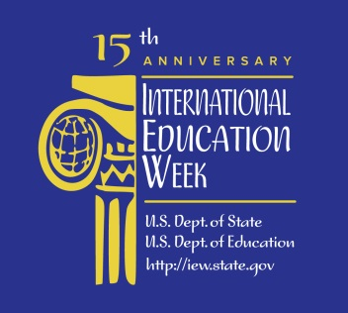

MCC LIBRARIES RESOURCES FOR PICTURE YOURSELF IN ICELAND!

Website:
- Visit Iceland: Official Tourism Information Site: http://www.visiticeland.com/

MCC Libraries Resources:

Del Giudice, Marguerite. "Power Struggle: The People of Iceland Awaken to a Stark Choice: Exploit a Wealth of Clean Energy or Keep Their Landscape Pristine?" National Geographic 2008: 62. Academic OneFile. Web. 5 Nov. 2014. <http://tinyurl.com/qec7p24>.

Gannij, Joan, and Rose Baring. Iceland, Finland & the Baltic. London: Cadogan Guides, 2005. Print. - LeRoy V. Good Library (currently in the International Education Week display on the main floor; later on the 3rd floor) - DL315 .F549 2005

Iceland. Petaluma, Calif.: World Trade Press, 2010. Ebrary. Web. 5 Nov. 2014. <http://tinyurl.com/ndxwdlk>.

"Iceland's Saga [Interview with Iceland President Ólafur Ragnar Grímsson]." Foreign Affairs 93.1 (2014): 142-150. Military & Government Collection. Web. 5 Nov. 2014. <http://tinyurl.com/oem37lv>.

Jónsson, Ásgeir. Why Iceland? New York: McGraw-Hill, 2009. Print. - LeRoy V. Good Library (currently in the International Education Week display on the main floor; later on the 3rd floor) - HB3722 .J66 2009

Lacy, Terry G. Ring of Seasons: Iceland, Its Culture and History. Ann Arbor: U. Michigan Press, 2000. Print. - LeRoy V. Good Library (3rd floor) - DL326 .L33 2000

Leffman, David. The Rough Guide to Iceland. 4th ed. London: Rough Guides, 2010. Print. - LeRoy V. Good Library (currently in the International Education Week display on the main floor; later on the 3rd floor) - DL315 .L443 2010

Leffman, David. Top 10 Iceland. New York: DK Pub., 2010. Print. - LeRoy V. Good Library (currently in the International Education Week display on the main floor; later on the 3rd floor) - DL315 .L44 2010

Loftsdóttir, Kristín. "The Loss of Innocence: The Icelandic Financial Crisis and Colonial Past." Anthropology Today 26.6 (2010): 9-13. Academic Search Complete. Web. 5 Nov. 2014. <http://tinyurl.com/k9c9wau>.

Magnússon, Sigurður G. Wasteland with Words: A Social History of Iceland. London: Reaktion Books, 2010. Print. - LeRoy V. Good Library (currently in the International Education Week display on the main floor; later on the 3rd floor) - DL338 .M34 2010

Oslund, Karen. Iceland Imagined: Nature, Culture, and Storytelling in the North Atlantic. Seattle: U. Washington Press, 2011. Print. – Damon City Campus Learning Commons - City GF645.I25 O75 2011

“World Factbook: Iceland.” World Factbook. Central Intelligence Agency, 20 June 2014. Web. 6 Nov. 2014. <http://tinyurl.com/3xc2tr>.

