

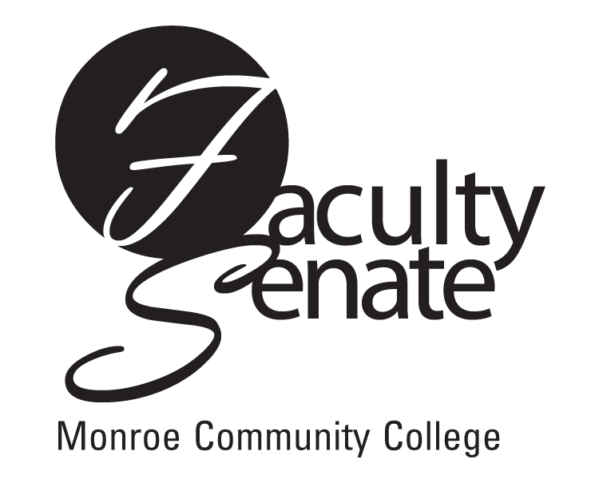 All College
Faculty Senate Agenda
Warshof Conference Center
Monroe A
October 18, 2007
3:30 p.m.

- All College Faculty Meeting

2. Announcements

3. Approval of Minutes from September Faculty Senate Meeting

4. Action Items:
Curriculum – PR13S Computer Information Systems, AAS
PR14S Engineering Science – Electrical Option, AS
Senior Citizen Audit Policy

5. Standing Committee Reports

6. Student Announcements

7. Old Business
Summary of the Ad Hoc Textbook Committee Report
Other

- New Business
Other

