DISCOUNTS AVAILABLE FOR
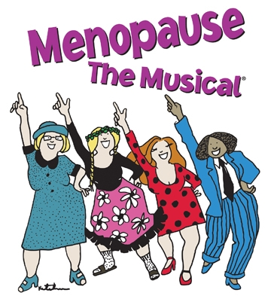

NOW EXTENDED THRU AUGUST 17!!
The Story: This musical comedy follows four women at a lingerie sale with nothing in common but a black lace bra AND hot flashes, night sweats, memory loss, not enough sex, too much sex and more. With guts and gusto, they sing their way through the challenges of "The Change" in a celebration of shared experience.
Fine print: America's #1 Girls' Night Out!

$45 for Orchestra Seating,
$40 for Section B – Balcony ($4.00 discount).
OR
Friday or Saturday evenings thru August 2 tickets are just $39 or $34 ($10.00 discount!)

For more information or to order tickets contact Colleen Brown at 585-232-1366 ext. 3057 or email to cbrown@gevatheatre.org. Mention promo code when ordering: Group MTM $4 off/Group MTM $10 off.
(Not valid on prior purchases)

