THE SOCIOLOGY FILM SERIES AT DCC PRESENTS MCC ALUMNUS
NICHOLLE LAVANN AND HER FILM
HOMICIDEZ

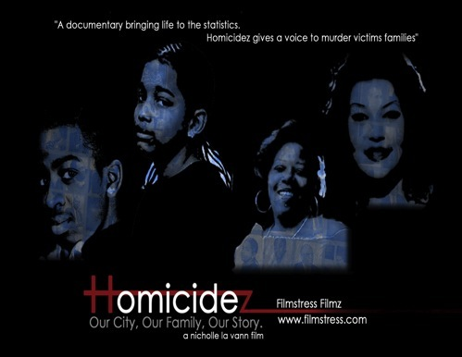

f

Film synopsis:
“Homicidez” a documentary of those experiencing violence in our cities, takes a composite look at people’s experience with social violence in the community where we live. “Homicidez” is filmed in Rochester, NY, a model city of wealthy outer zones of comfort and safety and poor inner zones where daily acts of violence are life long traumas to some, yet, merely routine maintenance to others. Film Director/Producer Nicholle La Vann of Filmstress Filmz, was inspired to make this film when her heart and spirit of humanity was awakened by the tragic horror of one truly outrageous incident. She felt she had to do something that would serve to awaken others to the importance of connection compared to smug isolation. The film presents many forums-people, government, law enforcement, medical, spiritual, artistic - that present different views and experience with inner city violence.” (From http://web.me.com/filmstress/Filmstress/Homicidez.html)

DATE: Wednesday, April 29, 2009
TIME: 3:00pm – view film with discussion to follow
PLACE: Room 4151 Damon City Campus
DISCUSSANTS: Filmmaker Nicholle LaVann and Christine Plumeri (Sociology)

This special event is free and open to the public. Given the topic, children are not invited. Faculty and staff, please encourage student attendance.
Please direct any questions to Christine Plumeri at x1768 or cplumeri@monroecc.edu

