

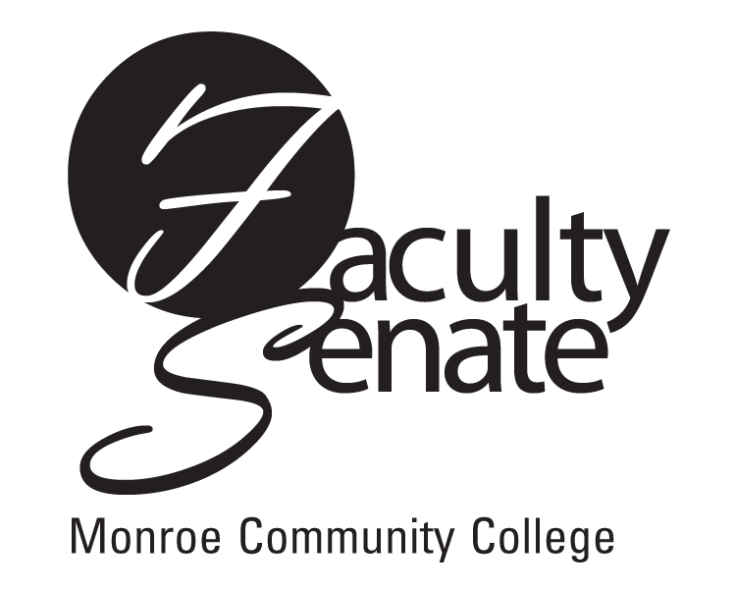 Faculty Senate Agenda
Warshof Conference Center
Empire Room
September 20, 2007
3:30 p.m.

- Guest Speakers – Betsy Ripton, Michael Quinn & Melissa Barbara – Attendance Reporting

- Announcements

- Action Items:
Curriculum – NP2S Honors Studies
PD1F Public Administration, AAS
PD3S Call Center Customer Service, Certificate

4. Approval of Minutes from June All College Faculty Senate Meeting

5. Standing Committee Reports

6. Student Announcements

7. Old Business
Senior Citizen Audit Policy
Other

- New Business
Smoking Policy
Other

