Fifth Annual Student Playwriting Competition

Call for Original One-Act Play Scripts

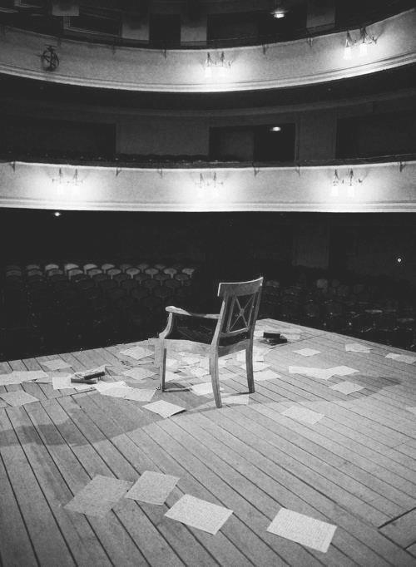

Submission Deadline: April 6, 2012

Winning scripts receive staged reading at an Awards Ceremony on May 3, 2012
Winning playwrights receive cash awards

Submission Guidelines
- Playwright must be an MCC student during Fall 2011 or Spring 2012 semester
- Only one-act stage plays accepted (3000 word limit)
- All submissions must include a title page with author’s name, home address, campus address, e-mail address, and phone number
- All materials submitted must be original and previously unpublished in any but college publications

Please submit materials to Tina Morrill, 5-532, Brighton Campus or
Anne Kirkpatrick, 4225, Damon City Campus

All contestants will be notified by April 27

Please direct questions to Gail Bouk (gbouk@monroecc.edu) or Midge Marshall (mmarshall@monroecc.edu).

Sponsored by The Sixth Act and The Creative Arts Committee

