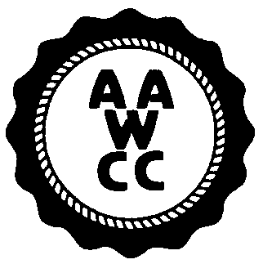Monroe Community College

TAKE OUR DAUGHTERS AND SONS TO WORK DAY

THURSDAY, APRIL 26, 2007

Presenter/Program Sheet – Damon campus

Sponsored by the Monroe Community College chapter of the American Association for Women in Community Colleges (AAWCC)

Presenter’s Name:

Dept. Phone:

Co-presenter/Assistant:

Location: ____Brighton Campus ____Damon City Campus

Program Title:

Brief Program Description:

Times available (programs run 50-60 minutes):
- Choice 1:
- Choice 2:

Preferred location:
- Classroom
- Gym
- Other ______________________________

Special Needs:

Appropriate age range:

I cannot conduct a workshop but I can:
Help in the planning □ Help the day of the workshop □

Please complete this form and return it to Vilma Morrow, DCC by March 16, 2007. Someone will get back to you to confirm all arrangements. On behalf of AAWCC and the young people in our community, thank you for your time, caring, and commitment to this worthwhile endeavor.

