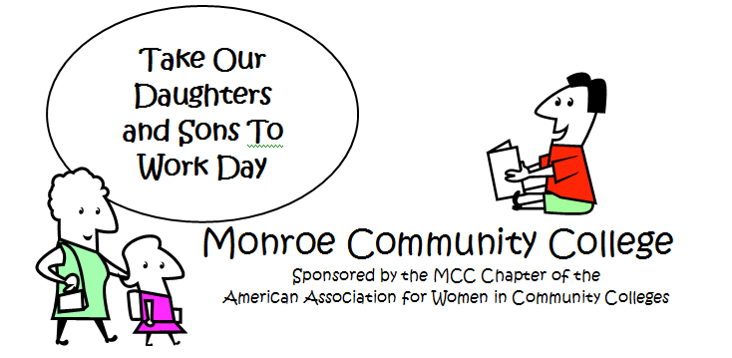

April 14, 2009

Thank you so much for your contribution to our Take Our Daughters and Sons to Work Day event. As you have heard and experienced, the day was a huge success! MCC hosted over 100 children between the Brighton and Damon City Campuses. We have received many positive compliments about the event and are looking forward to start planning for next year’s event.

Special highlights and thank you’s include:

- Presenters: You made this year’s theme of Building Partnerships to Educate and Empower an educational and engaging experience for all!
- Vice Presidents, Deans and Department Chairs: We couldn’t have done it without your contributions and support!
- Campus Center: Thank you for sponsoring Breakfast!
- Aramark: Thank you for sponsoring Lunch!
- Departments who donated items: Goodie Bags, Walkie-talkies, Emergency Phone/Keys, Photo paper, Folders, Name badges…you name it and you supplied it!
- Volunteers: Your dedication made everything run so smoothly and efficiently! Set-up/Registration, Breakfast/Lunch, Facilities, Photos, Escorts, First Aid, Command Center, Van Transportation, Career Center Display, Game Room Tokens, and all that prep work…super job!
- Last but not least, the TODASTWD Committee: Your dedication to make this a successful event is greatly appreciated and rewarding!

On behalf of the MCC Chapter of the American Association for Women in Community Colleges, we wish to thank all for donating your time and resources towards the education of MCC’s future students.

Sincerely,

Event Co-Chairs

Co-Chairs: Yolanda Johnson/Campus Events * Laura Coriddi/Computing. DCC Chair: Lisa Wallace/DCC Student Service* Donna Augustine/CSTEP. Presenter/Database Coordinator: Marie Gibson/Instructional Technologies.
Members: Vilma Morrow/Asst. Director Student Services-DCC * Nancy Soregi/Financial Aid * MaryJane Starr/Health Services * Sylvia Lavin/Services for Students w/Disabilities*Brigitte Martineau/Mathematics*Susan Fish/Admissions*Jon Seiler/Campus Events Intern.

Visit http://web.monroecc.edu/aawcc/tosadtwd to view the PowerPoint presentation of
amazing photos and fun!

