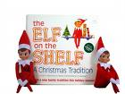


NOW Available at the MCC and DCC Bookstore
30% OFF
Excludes any other discount

