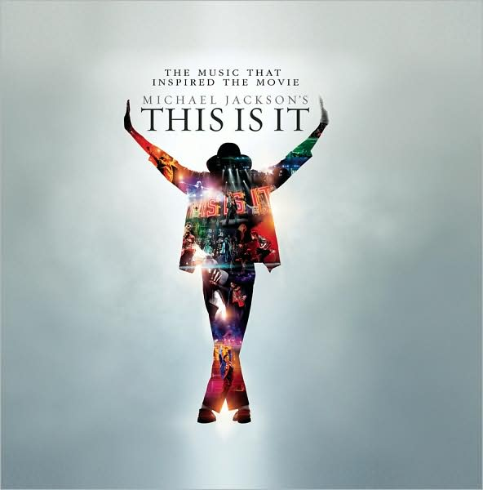

2CD Set
-Unreleased Rare Tracks
-Original Album Masters
-A 36-page book of exclusive rehearsal photos
30% OFF Suggested Retail

