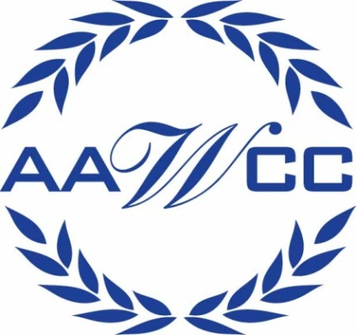

American Association of Women in Community Colleges presents:
Cheryl McKeiver on
“Women & Finances “
Presented at The Damon City Campus
Monday May 9th, 2011 from 3-4:30pm room 4193 (Community Room)
- This forum is open to all students, faculty and staff
- Light refreshments will be served


Cheryl McKeiver is a faculty member in the Business Administration and Economics Department at The College at Brockport, as well as a certified financial educator and lecturer. Formerly, she was Vice-President and Director of Training and Development at Citibank/Citicorp.
Cheryl has been an award -winning corporate training instructor for more than 25 years. She holds a BS in Human Resource Management from Roberts Wesleyan College and a MBA from Medaille College in Buffalo, NY. She is currently a doctoral candidate at Nova Southeastern University. For more information visit her website at (http://www.cherylmckeiver.com)
For more information contact: Beatriz LeBron @ 262-1759 or Tracey Britton @ 262-1741, AAWCC Professional Staff Development Co-Chairs

