Office of Online Learning
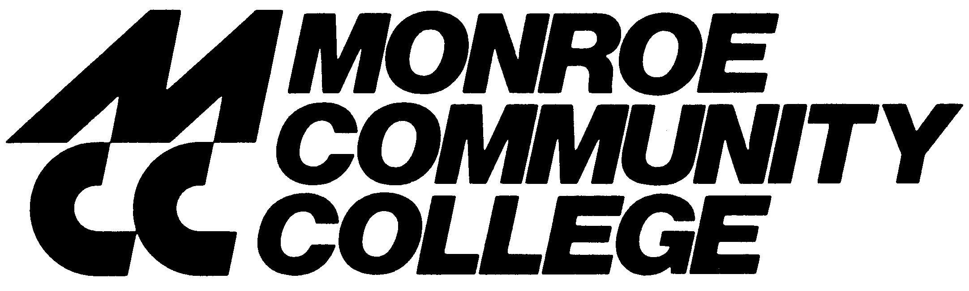

Spring 2011

Dear Student,

Welcome to Monroe Community College and the SUNY Learning Network (SLN)! At MCC we use a course management system called SLN ANGEL. To access your online course, go to
https://monroecc.sln.suny.edu/ and follow the log-in instructions on the ANGEL Logon page.

Please note that your course will not appear on your homepage until one week before the start of the course.

We encourage you to review the online course readiness checklist on the MCC website at http://www.monroecc.edu/depts/distlearn/minicrs/OnlineForm.htm to help you prepare for your first day of classes. You should also take some time to review our new “online tutorial” at http://www.monroecc.edu/depts/distlearn/BOSS.

Most courses can be accessed one week prior to the start date of the course to enable students to familiarize themselves with navigating the SLN courses and the course requirements. All courses include a section of Course Information Documents. It is very important for you to read these documents thoroughly before the start of classes. Please refer to the MCC Master Schedule or the course list at www.monroecc.edu/depts/distlearn/CourseList.htm for specific course start dates.

MCC also offers face-to-face orientation sessions on how to navigate your online course(s). If you are a first-time online student you are strongly advised to attend one of these orientation sessions to learn how to post discussions, submit assessments, access your online grade book, and other vital information. Orientation dates for Spring 2011 are:

Brighton Campus
Tuesday, January 18th Room 11-111 1:00 p.m. - 2:00 p.m.
Tuesday, January 18th Room 11-111 2:30 p.m. - 3:30 p.m.
Wednesday, January 19th Room 11-111 10:00 a.m. - 11:00 a.m.
Wednesday, January 19th Room 11-111 11:30 a.m. - 12:30 p.m.
Thursday, January 20th Room 11-111 4:30 p.m. - 5:30 p.m.
Thursday, January 20th Room 11-111 6:00 p.m. - 7:00 p.m.
Tuesday, January 25th Room 11-108 6:00 p.m. - 7:00 p.m.
Wednesday, January 26th Room 11-108 6:00 p.m. - 7:00 p.m.
Damon Campus
Friday, January 21st Room 5030 9:00 a.m. - 10:00 a.m.

Please contact the SLN Help Desk (1-800-875-6269) if you are having technical problems with your course. You can also contact the MCC Office of Online Learning at 585-292-3440 if you need additional assistance.

Sincerely,

Peggy VanKirk
Coordinator, Office of Online Learning

