Registration and Records
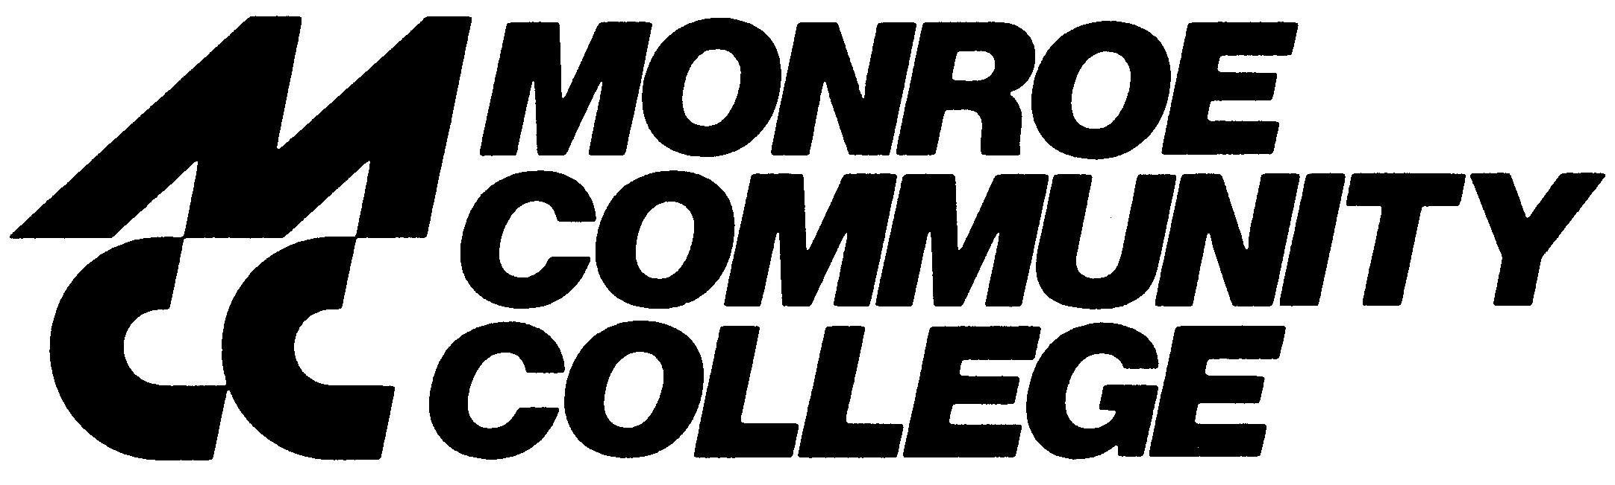

Spring 2008

Dear Student,

Welcome to Monroe Community College and the SUNY Learning Network (SLN)! At MCC there are currently two different course management systems for online courses, SLN Classic and SLN Angel, with two different log-in procedures. To log into your online course, go to www.monroecc.edu/depts/distlearn/CourseList.htm, click on the semester you want, then click on your individual course title and follow the instructions on the page.

It is important to log into your course as soon as possible because for SLN Classic, one of the two course management systems, you have to request a password and the last day you can do so is Friday, January 18th.

We encourage you to review the online course readiness checklist on the MCC website at http://www.monroecc.edu/depts/distlearn/minicrs/OnlineForm.htm to help you prepare for your first day of classes and ensure that all systems are Go!

MCC’s Brighton and Damon City Campuses also offer face-to-face orientation sessions on how to navigate your online course(s). Orientation dates for Spring 2008 are:

Brighton Campus
Tuesday, January 15 | room 11-111 | 2:30 pm - 4:00 pm
Wednesday, January 16 | room 11-111 | 10:30 am - noon
Thursday, January 17 | room 11-111 | 6:30 pm - 8:00 pm
Saturday, January 19 | room 11-111 | 10:30 am - noon
Thursday, January 24 | room 11-108 | 10:30 am – noon
Damon Campus
Friday, January 11 | room 5006 | 10:30 am - noon

Please contact the MCC Office of Online Learning at 585-292-3440 if you need assistance with your online course. The SLN Help Desk (1-800-875-6269) is also available to assist you.

You will be able to access your course(s) on January 15, 2008. Please refer to the Spring 2008 course list at www.sln.suny.edu for specific start dates. If you need further information, contact the Registration and Records Office at 585-292-2300. We can also be reached at SLNRegistration@monroecc.edu.

Sincerely,


Elizabeth Ripton
Director

