

Direction 1

Diversity Council

CDO
Diane M. Cecero

Co-chair
Charlotte Downing

Co-chair
Craig Rand

Carol Adams

Patrick Bates

Shirley
Batistta-Provost

Donald Beech

Marlene Fine

Marcia Fugate

Ann-Marie John

Peggy
Harvey-Lee

Fred McCullough

Deborah Mohr

Karen Morris

Emeterio M. Otero

Donna Pogroszewski

Christopher Otero-Piersante

JoAnn Santos

Richard Stewart

Bess Watts

Save the Date
November 9 & 10, 2009
Keynote Presentations & Workshops at the
Brighton & Damon City Campuses

Fifth Annual Alice Holloway Young, Ed.D. Power of Diversity Series
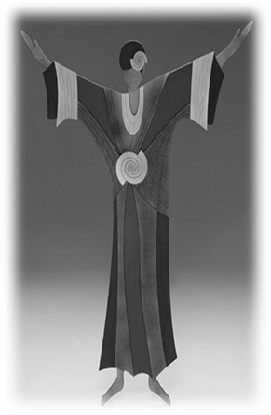

Supporting an Inclusive Campus Environment

Featuring
Beth Zemsky, MAEd, LICSW

The Alice Holloway Young, Ed.D. Diversity Series recognizes the pioneering spirit and outstanding leadership of Dr. Young, a leading Rochester educator, and founding trustee and board chair emerita of Monroe Community College.

