Monroe Community College Sustainability Steering Committee presents –

Recycling Beyond the Blue Box:

The Monroe County
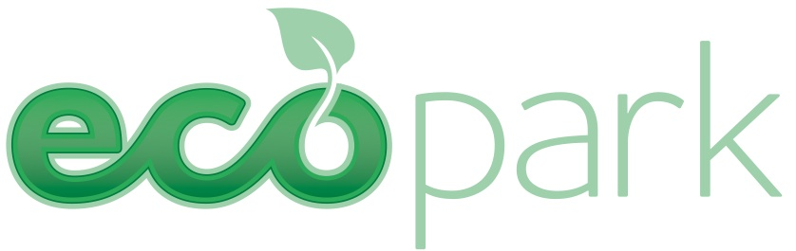

Join Thomas M. Sinclair, Industrial Waste Engineer and Household Hazardous Waste Coordinator from the Monroe County Dept. of Environmental Services to learn about this unique facility. This first of its kind in the nation facility collects Household Hazardous Waste, pharmaceutical wastes, scrap metal, bulky plastics, certified document shredding, used cooking oil and many difficult to recycle items.
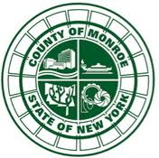

Monday, April 22, 2013 on Earth Day!
12:00pm
Monroe Community College
The Forum, 3-130

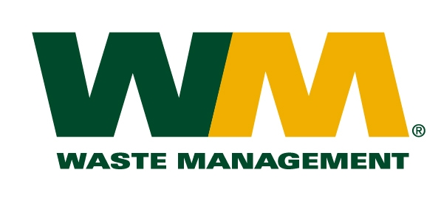


For information, contact: Jennifer Hill at jhill3@monroecc.edu or 292.2393

