
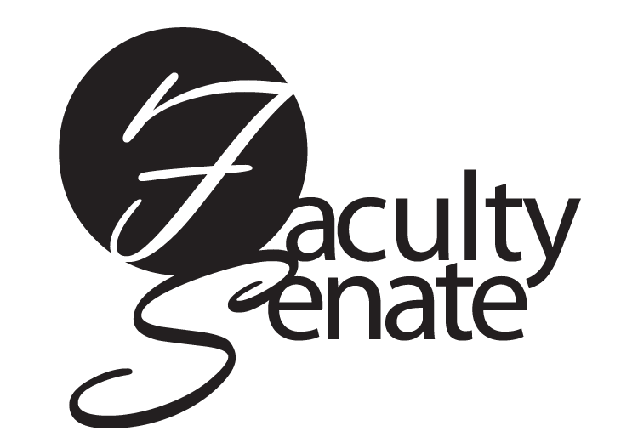
October 18, 2007

PRESENT: J. Alas, S. Batistta-Provost, D. Baxter, B. Connell, M. DiSano, J. Downer, K. Eirich, M. Ernsthausen, M. Ewanechko, S. Fess, M. Fine, M Fugate, E. Grissing, S. Hagreen, K. Huggins, A. John, N. Karolinski, R. Kennedy, D. Leach, A. Leopard, D. McConkey, J. McKenna, S. Murphy (Secretary), J. Nelson, P. Ornt, H. Pierre-Philippe, T. Schichler, D. Shaw, J. Striebich, A. Striegel, J. Thompson, M. Timmons, T. Tugel (President), J. Waasdorp, P. Wakem, C. Wendtland, H. Wheeler (Vice-President), W. Willard, W. Yanklowski.

ABSENT: I. Benz, P. Bishop, C. Boettrich,, S. Forsyth, M. Murphy, P. Peterson, E. Ripton, D. Smith, S. Weider, H. Wynn-Preische

GUESTS: J. Barone, S. Blacklaw, P. Burgess, S. Cable, D. Cecero, P. Collinge, K. Collins, R. Frye, T. Keys, A. Malone, M. Marino, K. Marhatta, M. McDonough, M. Miller, A. Morris, E. Morris, M. Ofsowitz, N. Primo, E. Putnam, M. Reyes, D. Robertson, R. Rodriguez, T. Shamblin , B. Smith, R. Stewart, J. Sturnick, S. Thompson, P. VanKirk, H. Williams

STUDENT REPRESENTATIVES: J. Bickel, R. Quider

- Meeting called to order: 3:36 p.m

- All College Meeting: T. Tugel

  - Terri Tugel expressed thanks to R. Degus for providing refreshments for today’s All College meeting.
  - The next All College meeting will be held in June 2008.
  - T. Tugel and Holly Wheeler met with DCC faculty on October 15, 2007 so that faculty could share issues and concerns with the Faculty Senate. T. Tugel shared these with the Senate:
    - Faculty at DCC feel the lack of progress in addressing their concerns may have a negative impact on student success and faculty working conditions
    - Availability of affordable child care continues to be a problem for students
    - Most food services in the Sibley building are gone
    - There are parking problems for students
    - Faculty have suggested that a shuttle be instituted between Brighton and DCC but this option has not been addressed
    - There are no on site health services
    - DCC does not have an admissions counselor on site. This leads to slow resolution of problems
    - Faculty at DCC perceive they are alienated from the Brighton campus and too often the College is viewed as separate institutions rather than different campuses of the same college.
    - There have been anecdotal reports that Brighton faculty and staff have discouraged students from enrolling in course at DCC.

D. All College Meeting held at Brighton-Issues and Concerns from Faculty
1. DCC concerns-
    - S. Cable encouraged the faculty at the Brighton campus to make the downtown campus and its viability a critical priority in the upcoming presidential search. The Damon community needs the support of the Brighton community. There is a sense that Damon faculty and students are isolated from the Brighton campus, and they struggle with perceptions that the Damon campus has a second-class status. It appears that some Brighton folk are unaware of or indifferent to Damon's issues, and some exhibit open hostility toward DCC. There have been reports of Brighton people actively discouraging students from enrolling at DCC. She encouraged Brighton faculty to visit DCC to get a sense of what the Damon experience is like.
    - Students have reported they were advised to switch majors in order to stay at Brighton.
    - As faculty how can we encourage support of each other? How as departments could we build collegiality with our DCC colleagues and to address concerns as a united faculty?
    - Attitudes are influenced by leadership. Perhaps a new president can influence a change.
    - How are the other College areas viewed such as the PSTF and Applied Tech Center? D. Cecero responded that these are “sites” and not campuses.
    - Perhaps we need to ask the question “why do people feel this way about DCC?” We need to answer this before a solution can be found.
    - It appears from the concerns raised today that there are fewer services at DCC which can impact student success. Can we make changes now? Basic needs need to be met.
    - What about day care? Renaissance Square does not include plans for a day care center.
    - A larger campus should have more services but at what point do they become disproportionate? PAETEC will be constructing a new building on the Midtown site. Could we work with them on these day care issues?
    - Departments can help by working with their faculty on both campuses. Encourage Brighton faculty to go down and visit DCC.
2. T. Tugel was concerned about the reduction of woodlands and wildlife area around the college. The space is becoming smaller and smaller due to the construction of the ESL ice rink, residence halls and more recently, a disc golf course. Some departments use this area for classroom activities and find the available space to do so decreasing. The Biology department believes that when decisions are made, there needs to be more investigation as to how the decision will impact other areas of the College.
3. S. Murphy noted that there were changes in the services of the Brighton Room. D. Cecero suggested that comments could be sent to Annette Agness in the Campus Center (aagness@monroecc.edu) or Andy Cole, Aramark (acole@monroecc.edu).
4. H. Wheeler voiced a complaint related to classroom space. Some classrooms consistently do not have enough desks. Students have to stand and there is no room for additional desks. This is counter-intuitive to student success. Inquiry into this problem results in answers such as “some students will drop”. This problem occurs every semester.
5. A concern was raised about the three-year post-tenure review materials. Submissions have been returned to faculty because they are deemed insufficient by the Vice-President. The FA contract states that a three-year review must be submitted but does not address its evaluation. Since this is an issue that falls under the contract it is best addressed by the Faculty Association, not the Faculty Senate.
6. Building 9A has floor tiles that are broken in many places and need repair. Efforts have been made to notify the appropriate areas but to date there hasn’t been a response
7. W. Yanklowski-The Engineering Technologies department has been identified by the administration as academically unviable. How will the Senate be involved? T. Tugel responded that SCAA has been notified regarding proposed curricular realignments.
8. T. Tugel thanked all faculty for attending the meeting and encouraged faculty to express their opinion about the presidential search by partaking in the survey and open forums.

III. Announcements: T. Tugel

A. Mary Timmons, chair of SCAA, encouraged everyone to take the presidential search survey which is due October 26, 2007. There is one more presidential search open forum at DCC on October 24, 2007.
B. Lee Struble is chairing a steering committee on civility issues. Per his request, the EC forwarded a list of teaching faculty on the Brighton campus to be part of a civility focus group. This list was generated from names recommended by department chairs and attempts to provide a broad-based representation of the focus group requested. A civility focus group for DCC will be formed at a later date.

IV. Action Items:
- Curriculum action item:
  - PR 13S Computer Information Systems AAS, motion passed.
  - PR1F Engineering Science-Electrical Option AS, motion passed.

- 1.2.2 Senior citizen Audit Policy

Current Resolution:
Anyone age 60 or over may audit MCC courses without tuition cost providing their presence in class does not deny enrollment to a student registered for credit. All Senior Citizens Audit Policy requests must be approved by the faculty teaching the course to be audited.

Proposed Change:
Anyone age 60 or over may audit MCC courses without tuition cost providing their presence in class does not deny enrollment to a student registered for credit. Permission to audit will be granted by the Counseling and Advising Center on the last official add day of each semester based on appropriate pre-requisite(s) and available class space. Faculty members will be notified of seniors auditing their classes by the Counseling and Advising Center.

Motion passed.

V. Approval of Minutes: Minutes of September 20, 2007 Faculty Senate Meeting approved as written.

VI. Standing Committee Reports

Academic Policies Committee – W. Willard
- W Willard clarified a point related to the senior citizen audit policy. She said that the NYS education law states that senior citizens may be permitted to audit courses on a space available basis provided the audit attendance does not deny course attendance to registered, matriculated students. So part of the reason for the change to the audit policy was to balance out the needs of senior auditors while also not denying a seat in the class to a registered, matriculated student.
- The committee has been working on changes to the language of the student grievance policy.
- W. Willard presented the academic calendar options for the years 2009-2010 and 2010-2011. She pointed out a major difference for the 2009-2010 calendar. For that year, Saturday, December 19, 2009 will need to be used as a final exam day for Saturday and non-Saturday classes as well. The calendars will be voted on at the next Faculty Senate meeting.

Curriculum – A. Leopard
A. The Curriculum Committee has given final approval to two new courses:
NC11S ART 110 Comics and Sequential
NC10S AAD 256 Motion Graphics

B. The Curriculum Committee has posted two course revisions:
CR99S CDL100 Career Development and Life Planning
CR1F HED 207 Emotional Wellness
NEG – H. Pierre-Philippe

No report.

SCAA -- M. Timmons
No report- see announcements.

Planning – E. Grissing
The committee will be discussing renovation plans for Building 9 such as classroom size and needs. If there are any departments who have any interest/concerns/issues related to Building 9 please contact Ed Grissing.

Professional Development – B. Connell
The committee has been reviewing the Professional Development resolutions to determine if any changes need to be made. Some of the dates for the awards have been changed. The Senate web site will be updated soon with the dates.

VII. Student Announcements
Ron Quider, Vice-President , Brighton Campus Student Government Association, announced that they were working on the Rock To Vote campaign and would be contacting departments to help. Any questions could be sent to Devon Lynch (dlynch041@student.monroecc.edu)

VIII. Old Business

T. Tugel: An Ad Hoc Bookstore Committee presented a report to the EC in 2006. One of the recommendations was to follow-up with a survey of students and faculty. The student survey was five questions that were added to the SUNY Student Opinion survey. Terri shared some of the survey results:
- 66% satisfied or very satisfied with the bookstore
- 49% buy texts only from the MCC bookstore
- 27% frequently buy elsewhere due to lower costs
- 80% are interested in ordering books online
- 66% reported books are always or usually available by the end of the first week of class
- 65% prefer used books over new ones
- 20% had no preference
The Ad Hoc Committee recommended that the bookstore investigate an on-line ordering system.
A faculty survey was also conducted in the fall of 2006. A portion of the results are as follows:
- 2/3 reported satisfied or very satisfied with textbook ordering and supply
- Book Orders
- 71% sufficient books ordered
- 80% orders were completed as requested
- 35% check the bookstore prior to the semester start
- 55% said textbook price was somewhat influential in selection
The purpose of the survey was to try to gain a better understanding of how widespread any bookstore problems might be. The survey results were inconclusive and no single campus –wide problems were identified. The EC is recommending bookstore issues at this time are better addressed at the department level. A suggestion would be to have a bookstore representative meet with the department. It was noted that since the ad hoc committee made their initial report, communication from the bookstore.

IX. New Business
D. Cecero-The Diversity Council has organized an Alice Holloway Young Ed.D. Diversity series two day presentation which will feature Gary R. Howard. On November 15, 2007 at DCC there will be a workshop and keynote presentation by Mr. Howard and a workshop at Brighton. A keynote presentation will be held at Brighton on November 16.

Meeting adjourned at 4:55 p.m.

Respectfully submitted,

Terri Tugel Susan Murphy
President Secretary

Minutes approved at the November 15, 2007 Faculty Senate meeting.

