Military Advocacy Program
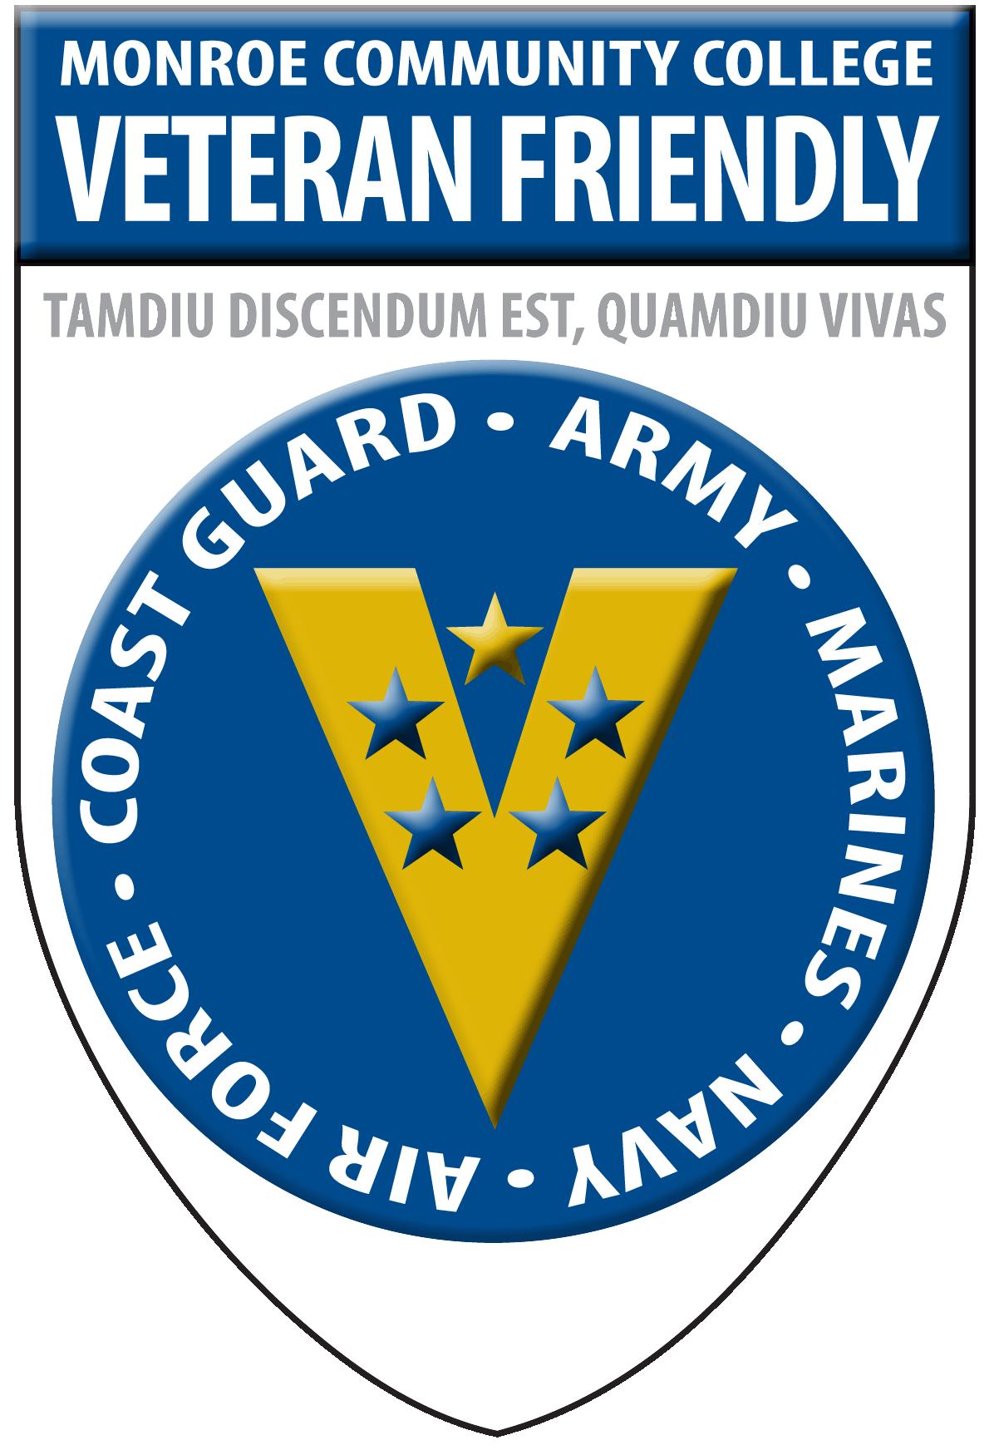

What is the Military Advocacy Program (MAP)?
The MAP helps connect military students (service members, spouses, dependents and family members) with Monroe Community College’s academic resources, faculty members, and/or social media platforms so military students can better negotiate a fully civilian/academic environment. In so doing, we hope to increase the student’s completion, transferability and (ultimately) professional success.

Connect with academic resources!
  - academic tutoring, writing and research help will be available by request in the new Veterans’ Resource Center in the Leroy V. Good Library at Brighton Campus
  - simply send an email to the MAP Facilitator, Prof. Heather Williams, and she will arrange a military-friendly tutor from that discipline - hwilliams@monroecc.edu
  - your request should include:
    - your name
    - a brief description of the assignment
    - a brief description of the specific aspect of the assignment you want the tutor to address
Connect with an actual person!
  - a military-friendly faculty member will serve as your “go to” point person at MCC, a general sounding board, “battle buddy”, coffee companion, and overall college coach.
  - Simply tell any of the following MCC faculty/staff members that you would like an MAP Mentor, and they will have you fill out the request form. You will receive a message in your MCC email inbox letting you know who your Mentor is. From that point forward, all you’ll need to do is respond in a timely manner to any emails, follow through with any arranged meetings, and generally keep your Mentor in the loop. The two of you will work out the logistics based on what works best for you and your needs.
    - Prof. Heather Williams, MMP Facilitator - hwilliams@monroecc.edu
    - Michael Bates, Veterans Services Director - mbates@monroecc.edu
    - Prof. Eric Wheeler, Academy for Veterans Success Coordinator - ewheeler@monroecc.edu
    - Lori Bartkovich, Veterans Services Specialist - lbartkovich@monroecc.edu
  - If you are already interacting with a faculty member who you know to be an MAP Mentor, you can also request that Mentor specifically, through them.

Connect with Facebook!

  - “like” the organization Facebook page
    - this Facebook page is purely administrative
    - you’ll find posts about helpful academic tips as well as events, celebrations and news articles from MCC, colleges nationwide, and general higher education sources relevant to military students
    - https://www.facebook.com/MilitaryAdvocacyProgramAtMonroeCommunityCollege

  - “friend” the personal Facebook page
    - this Facebook page is more interactive and serves as a “virtual” Mentor
    - the MAP is able to respond to your posts and pictures, extend congratulations, share birthday greetings and respond to private Facebook messages
    - https://www.facebook.com/map.mcc

