

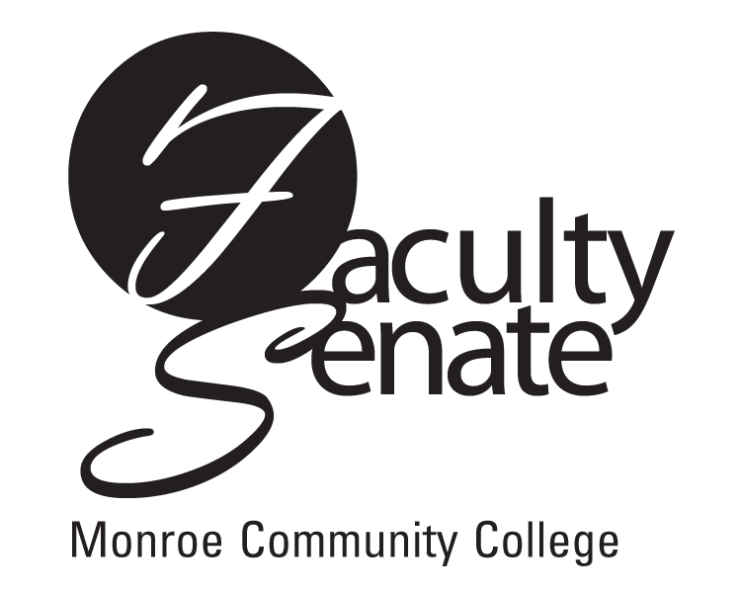 All College Faculty Senate Agenda
Warshof Conference Center
Monroe A
June 14, 2007
3:30 p.m.

- Guest: President R. Thomas Flynn

- Announcements

3. Action Items:
Curriculum: REA 101 Course Revision
SCAA: Resolution 5.2.5

4. Approval of Minutes from May Faculty Senate Meeting

5. Standing Committee Reports

6. Student Announcements

7. Old Business
Other

- New Business
Other

