“
“Enriching
Advisement:
The
Workshop
Series"
In June

Please join us for our 1/2 Day
Academic Advisement Workshop!

Friday, June 7, 2013

- Registration (coffee & bagels)
8:00 a.m. – 8:30 a.m., Bldg. 9 Lobby – 1st floor
- Session #1: 8:30 a.m. – 10:00 a.m.
- Session #2: 10:15 a.m. – end
- Luncheon: 11:30 p.m. – end
Forum (Bldg. 3-130)

“Knowing is not enough, we must apply.
Willing is not enough, we must do.”
--Goethe

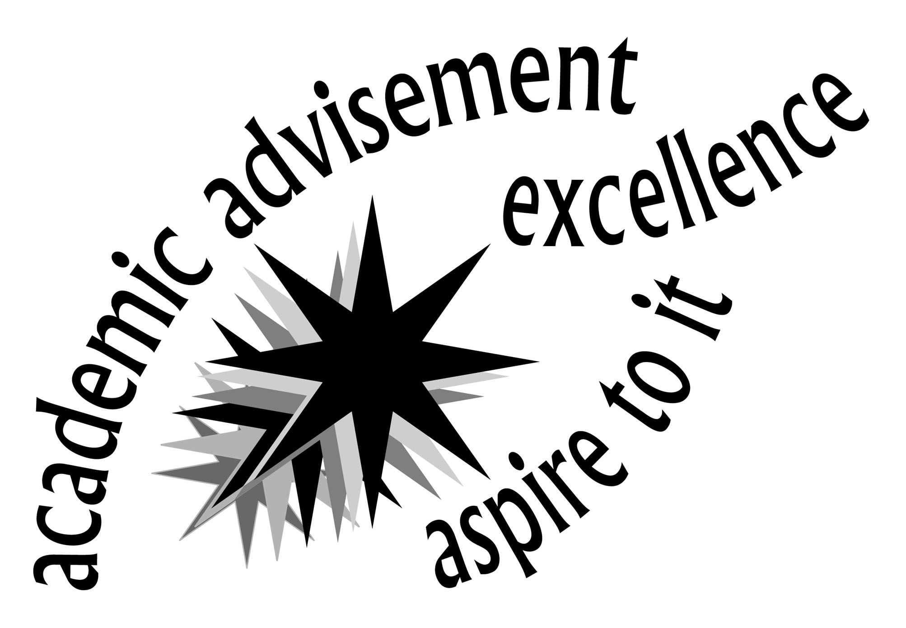

- Review the attached list of workshops.

- Return attachment to Michele Vitale (Advising & Graduation Services) Bldg. 1-231
or mvitale@monroecc.edu to RSVP and indicate your workshop selections.

Questions, please call:

Denise Klein (x2402), dklein@monroecc.edu
ADV 001, ADVISEMENT CENTER-GETTING STARTED
This workshop will introduce you to the Advisement Center's set-up, operations & resources. Come learn how peer advisors and advisors will help support your experience in the Advisement Center.

ADV 101, INTRODUCTION TO ADVISEMENT
This workshop is designed to present faculty members the basic skills and tools used in academic advising. Some of the topics discussed include the advising process, the role of the advisor, appropriate course placement, course sequences, CAPP (Curriculum, Advising and Program Planning), placement testing, and audit forms. You are encouraged to attend to learn more about academic advising or to refresh your basic skills.

ADV 102, INTRODUCTION TO ACCUPLACER
This workshop will provide information on the placement testing process at the College. The presenter will interpret test scores, course placements (required, recommended, TRS), and demonstrate how to utilize this information to assist students in planning a schedule of courses consistent with their demonstrated academic abilities.

ADV 103, CAPP (Curriculum, Advising and Program Planning)
CAPP is the computerized student degree evaluation. Learn how to view, interpret and print this compliance so you can assist students in the advisement process. Learn what an attribute is, why they are important and how you can search for them in the master schedule of course offerings.

ADV 108, INTERPRETING HIGH SCHOOL TRANSCRIPTS
This workshop will introduce you to the Imaging software. This software provides viewing access to the student's academic transcripts (high school, college). Nuances with high school transcript evaluation will be discussed including: diploma type, identifying potential disabilities which may require some form of accommodation (learning, mobility, hearing), and strength of high school program.

ADV 111, ACADEMIC HISTORY & THE IMPACT ON FINANCIAL AID ELIGIBILITY
This workshop will help you to understand how a student’s academic history can impact Financial Aid.

ADV 115, HEALTH RELATED PROGRAM INFORMATION
This workshop will review the competitive admission process of MCC’s allied health programs (Nursing, Radiological Technology, Dental Assisting, and Dental Hygiene) in relation to advisement. Faculty will gain a better understanding of the prerequisites, quality point classes, and selection process.

ADV 121, CHOOSING THE FIRST MATHEMATICS COURSE
This workshop focuses on the information and tools faculty advisors need to determine the first mathematics course which students should take based on a mathematics placement level and requirements for degree programs. A redesigned and updated advising flowchart is used to share general advice and special tips for various scenarios.

ADV 124, DYNAMICS OF ADVISING VETERAN STUDENTS
This workshop is designed to assist faculty in recognizing the unique challenges faced by current and former members of the armed forces as they embark on college coursework. The session will provide an overview of military culture, available educational benefits, and common transition issues. Case studies will illustrate effective methods for assisting this student population.
ADV 125, CAREER AND PERSONAL COUNSELING CENTER SERVICES
Faculty are concerned about the increasing number of personal issues our students face and the impact this has on student success. This workshop is designed to assist faculty in recognizing and making referrals to the Counseling Center for students with personal and/or career-decision making issues.

ADV 126, INTRODUCTION TO THE CAREER CENTER SERVICES
This presentation will introduce faculty to the wealth of career, transfer, and job search services available to MCC students and alumni. The presentation will be held in the Career Library.

ADV 165, 2+2 ADVISING; WHAT YOU NEED TO ADVISE 2+2 STUDENTS
What is the advantage of a 2+2 program? How do you know if a student is eligible? Can 2+2 students take honors courses? This workshop is designed to provide a better understanding of the 2+2 programs available at MCC and how to advise those students interested in this option. Topics to be discussed include: eligibility, audit sheets, and other important advising tips. This workshop will clarify some of the confusing dilemmas faced when advising 2+2 students.

ADV 182, SUNY GENERAL EDUCATION
How do these requirements impact you as a faculty advisor? This workshop will explain the SUNY general education commitment at MCC historically, as well as discuss present and future implications. Included in this workshop is a discussion on waiver criteria.

ADV 196, UNDERSTANDING THE “INTERNATIONAL STUDENT” IN YOUR CLASSROOM
The term “International Student” is many times misunderstood. In this session you will learn the definitions and differences between: the non-immigrant F-1 international student (and other visa categories), the immigrant student (generally referred to as the ESOL student), and the undocumented student. Additionally, you will learn: concerns; support services available for each population; common cultural adjustment matters in the classroom; and how the immigration regulations may impact a student in your classroom.
ADV 200, HUMAN DEVELOPMENTAL MODELS AS APPLIES TO DEVELOPMENTAL ADVISEMENT I
Academic Advising is a developmental process which assists students in the clarification of their life and career goals and in the development of educational plans for the attainment of these goals. This workshop reviews developmental verses prescriptive advising, ideas on the "whole" student, student development theory and concepts, and the roles of the advisor and advisee. It is designed for those who want to further refine their advising skills.

ADV 201, STUDENT LEGAL ISSUES IN ADVISEMENT
This workshop will describe an advisor’s responsibilities regarding student privacy, what you can and can’t reveal, and related legal issues.
Name ___________________________________________ Dept _________________________ Ext________

Workshop Check-In is located in Bldg. 9 – 1st Floor Lobby starting at 8:00 a.m. on Friday, June 7th

__________ Yes, I plan on attending Session #1 from 8:30 a.m. – 10:00 a.m.
__________ Yes, I plan on attending Session #2 from 10:15 a.m. – end
__________ Yes, I plan on attending the luncheon from 11:30 p.m. – end (Forum – Bldg. 3-103)

Please indicate which sessions you are interested in attending
(Rank two preferences in EACH session)

Session One: 8:30 – 10:00 a.m. Session Two: 10:15 - End
ADV 101 INTRODUCTION TO ADVISEMENT (Ornt)  ADV 102 INTRODUCTION TO ACCUPLACER (Raimondo)  ADV 103 CAPP (Curriculum, Advising and Program Planning) (Rock-McCrossen)  ADV 108 INTERPRETING HIGH SCHOOL TRANSCRIPTS (Slate)  ADV 111 ACADEMIC HISTORY & THE IMPACT ON FINANCIAL AID ELIGIBILITY (Schwartz)  ADV 124 DYNAMICS OF ADVISING VETERAN STUDENTS (Wheeler)  ADV 125 CAREER AND PERSONAL COUNSELING CENTER SERVICES (Bennett)  ADV 126 INTRODUCTION TO THE CAREER AND TRANSFER CENTER SERVICES (Hughes & Miller)  ADV 165 2+2 ADVISING; WHAT YOU NEED TO ADVISE 2+2 STUDENTS (Mack & Wynn-Preische)  ADV 182 SUNY GENERAL EDUCATION (Robbins)  ADV 196 UNDERSTANDING THE INTERNATIONAL STUDENT IN YOUR CLASSROOM (Dion)  ADV 200 DEVELOPMENTAL ADVISING THEORY (Dingee)  ADV 201 STUDENT LEGAL ISSUES IN ADVISEMENT (Cecero) | ADV 001 ADVISEMENT CENTER – GETTING STARTED (Ornt)  ADV 102 INTRODUCTION TO ACCUPLACER (Raimondo)  ADV 103 CAPP (Curriculum, Advising and Program Planning) (Rock-McCrossen)  ADV 108 INTERPRETING HIGH SCHOOL TRANSCRIPTS (Slate)  ADV 111 ACADEMIC HISTORY & THE IMPACT ON FINANCIAL AID ELIGIBILITY (Schwartz)  ADV 115 HEALTH RELATED PROGRAM INFORMATION (Kinslow)  ADV 121 CHOOSING THE FIRST MATHEMATICS COURSE (Adiletta & Wagner)  ADV 124 DYNAMICS OF ADVISING VETERAN STUDENTS (Wheeler)  ADV 125 CAREER AND PERSONAL COUNSELING CENTER SERVICES (Bennett)  ADV 126 INTRODUCTION TO THE CAREER AND TRANSFER CENTER SERVICES (Hughes & Miller)  ADV 165 2+2 ADVISING; WHAT YOU NEED TO ADVISE 2+2 STUDENTS (Mack & Wynn-Preische)  ADV 182 SUNY GENERAL EDUCATION (Robbins)  ADV 200 DEVELOPMENTAL ADVISING THEORY (Dingee)  ADV 201 STUDENT LEGAL ISSUES IN ADVISEMENT (Cecero)

PLEASE RETURN THIS FORM TO MICHELE VITALE (Bldg. 1-231, Advising & Graduation Services)
or e-mail to mvitale@monroecc.edu by Friday, May 31st.

You will receive confirmation of your registration and session assignments by Thursday, June 6th
via e-mail.

