Beginning in myMCC, go to the Banner tab and click Open Workflow in My Processes (or My Worklist, not pictured)
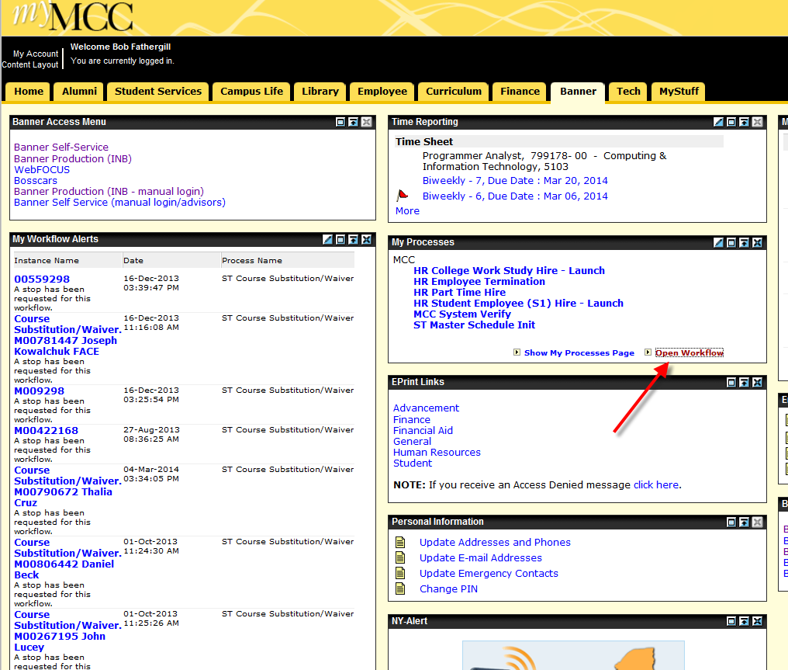

Workflow opens and the user should see a Worklist (possibly with no items) to the right and a menu (probably with fewer items than shown) to the left. Under User Profile, click User Information.
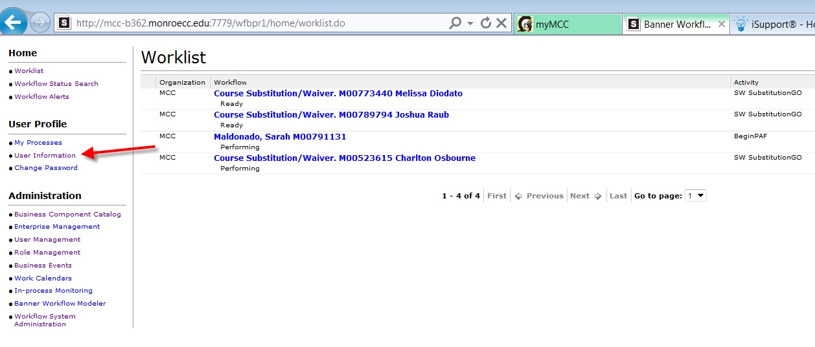
User should see basic profile info at the top, and a list of roles to which the user belongs. The particular user shown does not belong to the role in question, so see next page.
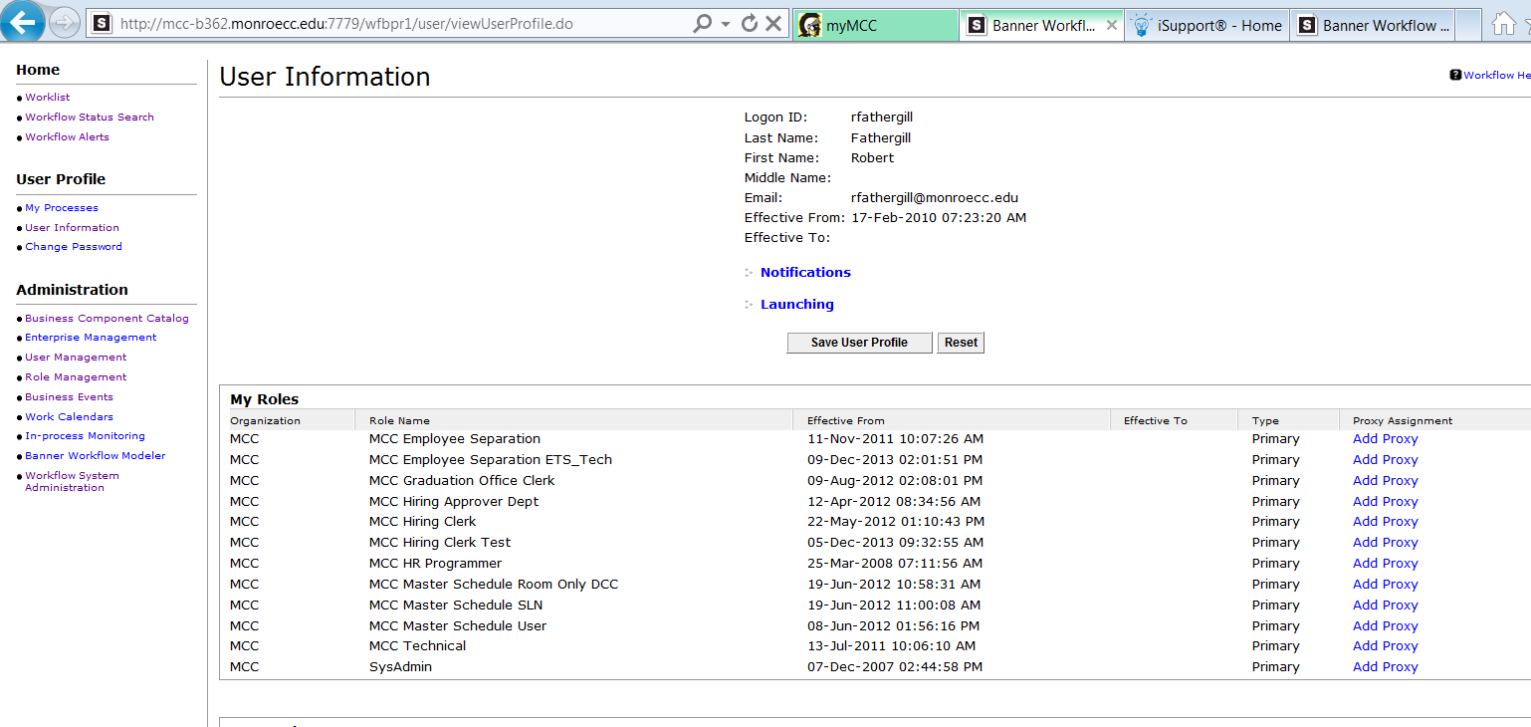

To use Dr. Bartkovich as an example, to assign a full-time proxy for approving part time hires at the budgetary/VP level, click Add Proxy for the MCC Hiring Budget Approver role.
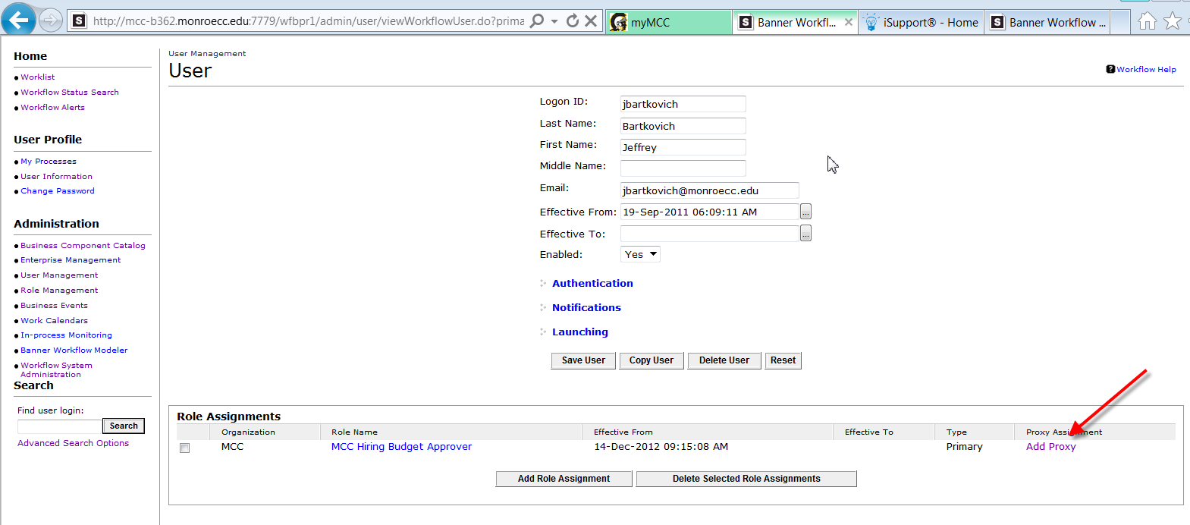
The Proxy Details page appears, offering a drop down for choosing a proxy from among other members of the role. NOTE: If the VP/Budgetary approver wants to assign a full time proxy to a user ID not shown in this list, we simply need to add that ID to the role. See Bob F for details.
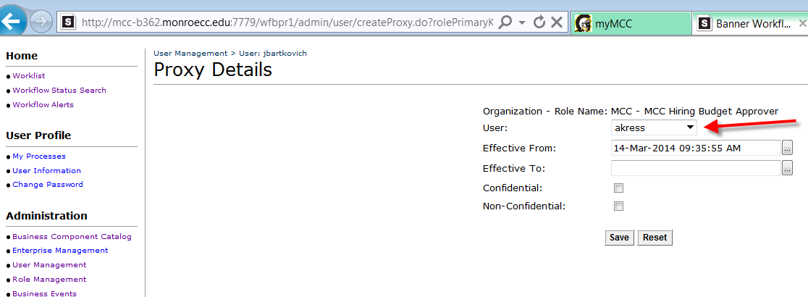

The window below shows the choices made for establishing a full-time proxy. All proxies in Workflow need to be given an Effective From and Effective To date. For full-time proxies, use the date shown (31-Dec-2099).
NOTE: The Confidential and Non-Confidential indicators refer to the proxy’s ability to approve workitems that have been flagged as Confidential or Non-Confidential. This determination is made at design time and thus far, no items have been flagged as Confidential. Personal information such as address, marital status, date of birth, social security numbers are not shared within workflow and should not appear on approval tasks. Should we begin using the Confidential indicator, however, checking both boxes now will assure that we need not do any updating later on.
Be sure to click the Save button.
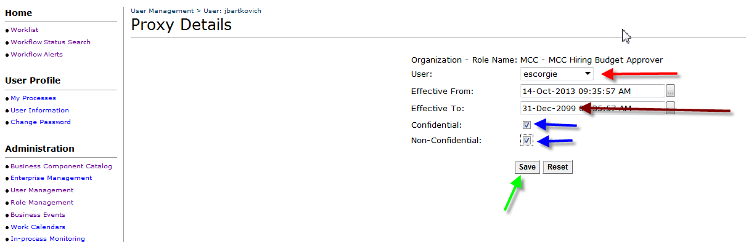

Click the Save User button
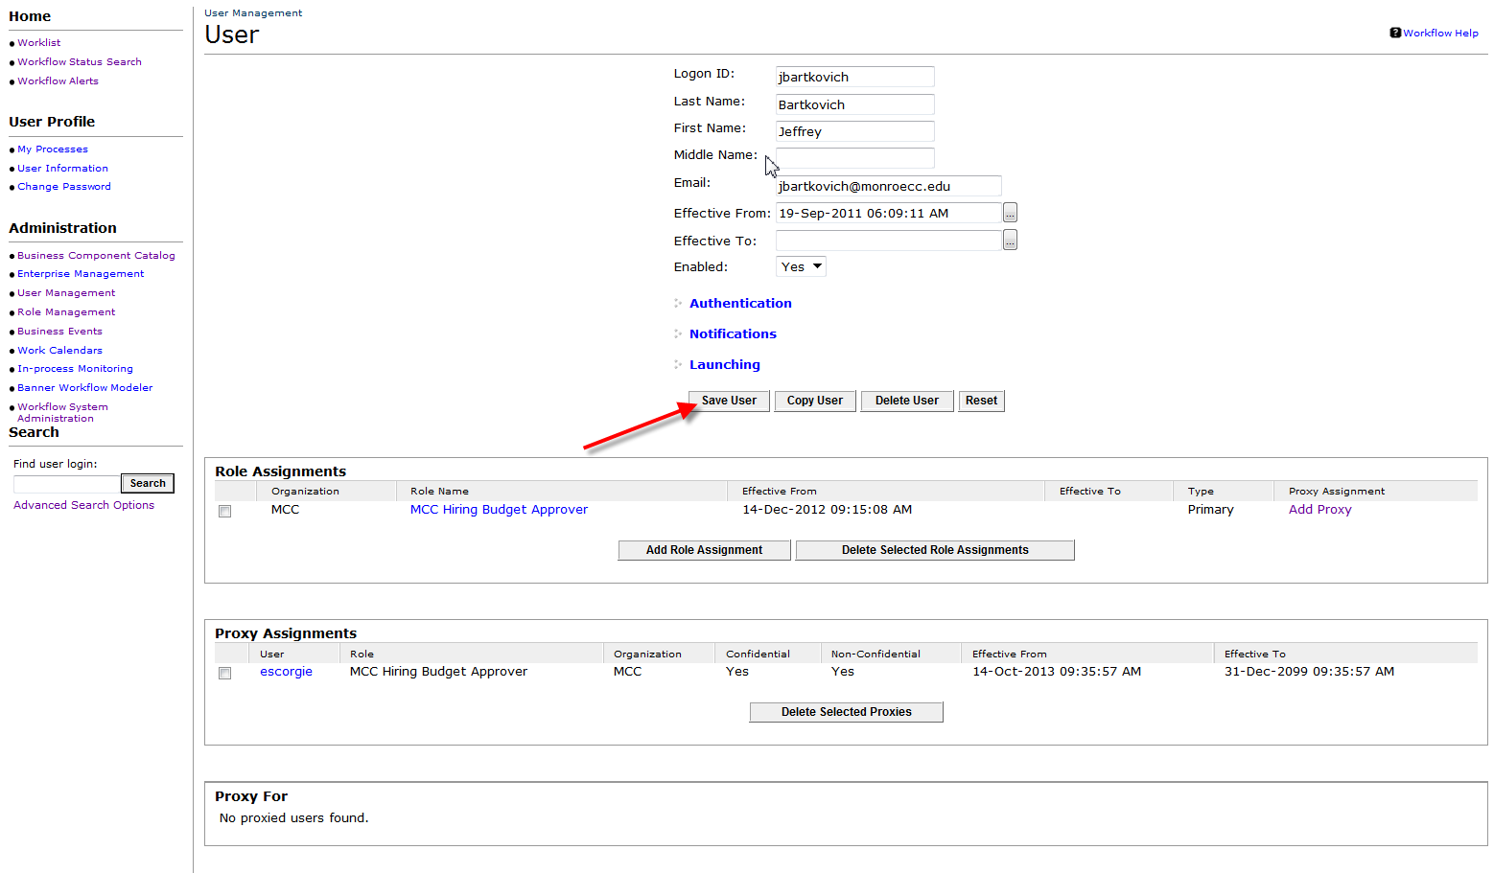

This sets up a Full Time Proxy.

