Find and click HR Part Time Hire in My Processes on the Banner tab.
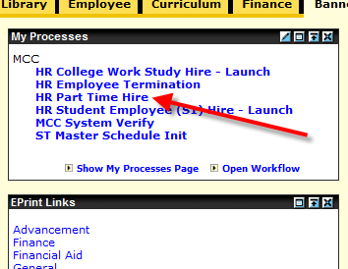

Read and follow instructions:
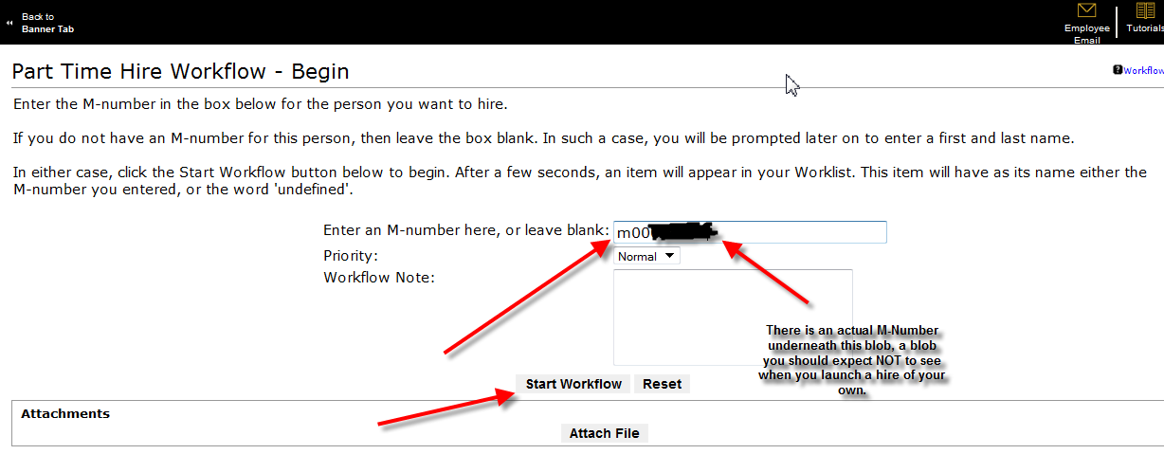

After clicking Start Workflow above, the screen below should appear. You need to click on Back to Banner Tab. (Clicking the OK button in the middle is optional and creates an extra step, so skip it).
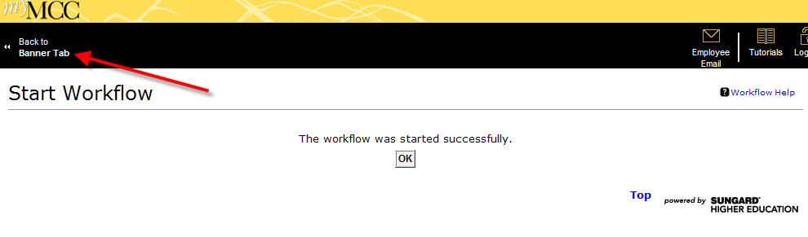
After clicking Back to Banner Tab above, the myMCC page reappears more or less as shown below. There should be a ConfirmName item (see the green arrow) in My Worklist, with a Workflow Name equal to the M-number (red arrow) you entered at the start. Click the M-number to see the name that goes with it.
There is the possibility that My Worklist may not yet show the ConfirmName item as shown below. This first step may take 5 to 15 seconds to complete, even during normal network traffic. If you don’t see it right away, you should click Refresh (blue arrow) until you do.
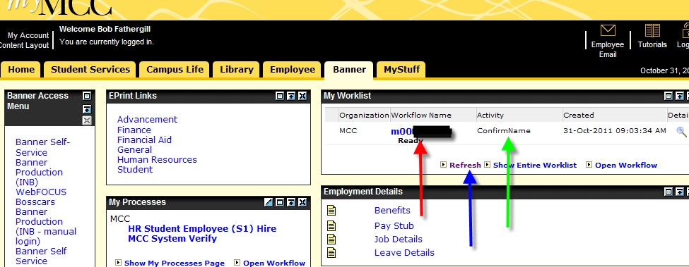

The Name Check shows the name that goes with the M-Number you entered (inside the green box). You need to choose either Yes or No under Choose One (note the asterisk indicating a Required choice). NOTE: If you choose No, and if that is because you mistyped the M-Number, you can retype the M-Number in the box suggested by the blue arrow. Then click the Complete button.
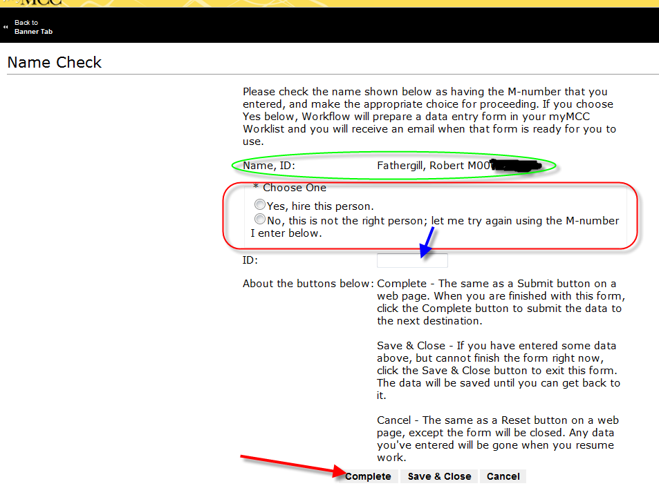

You should click Back to Banner Tab again. Your worklist should look like this (with nothing in it, unless you already had some items in it).
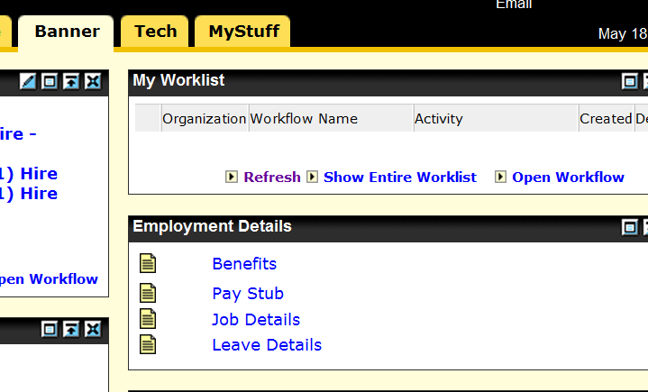

Workflow will be busy preparing the data entry form you will use to continue submitting this request. This will take a few moments because Workflow will be accessing Banner for a valid list of departments for you to choose from in identifying the Directory Department name and the Department to which timesheets (printed or electronic) will be delivered. Also Workflow is changing the name of this request so that you and others dealing with this hiring process will be able to see not just M-Numbers in your worklist, but also the names that accompany them. You will receive an email (which, unfortunately, may go to your Junk Folder) telling you when the form is ready in your worklist. Once you get that email (or after a couple minutes have passed if you don’t care about the email) click the Refresh button in My Worklist:
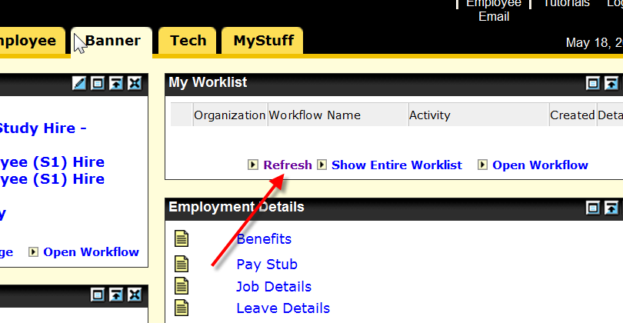

You should see something like this:
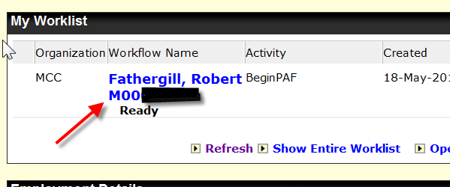
Click where the arrows tell you.
The top of the next page should look similar to the one below; as with the paper forms of the past, you need to identify the type of hire by clicking one, and then you need to define the charging elements. Fund is pre-populated and you can leave it alone. We’re not ready for you to try hiring someone FUNDed by a Grant code, but soon we will be and that is why this field is updatable. You need to specify an ORG and an ACCOUNT. Please take care to make the right choices to the best of your ability, as this will help the process complete more quickly.
If you specify a split distribution (2 or 3 combinations of FUND/ORG/ACCOUNT), the associated percentages MUST add up to 100, or you will probably see this page again.
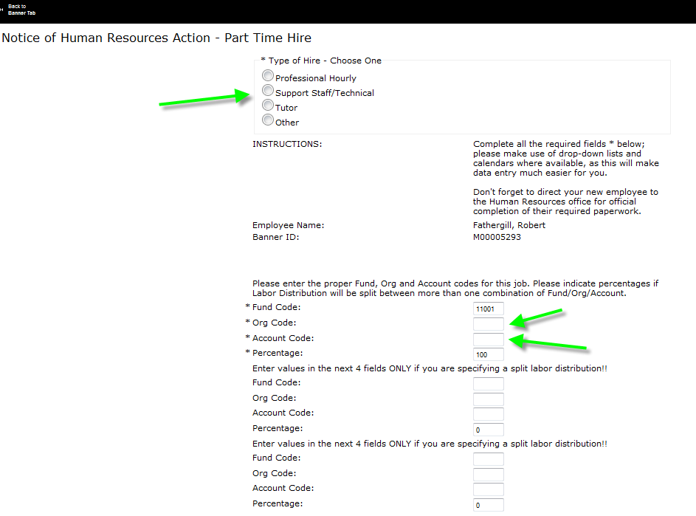

The rest of the page will resemble this. Please see the other hints that appear below.
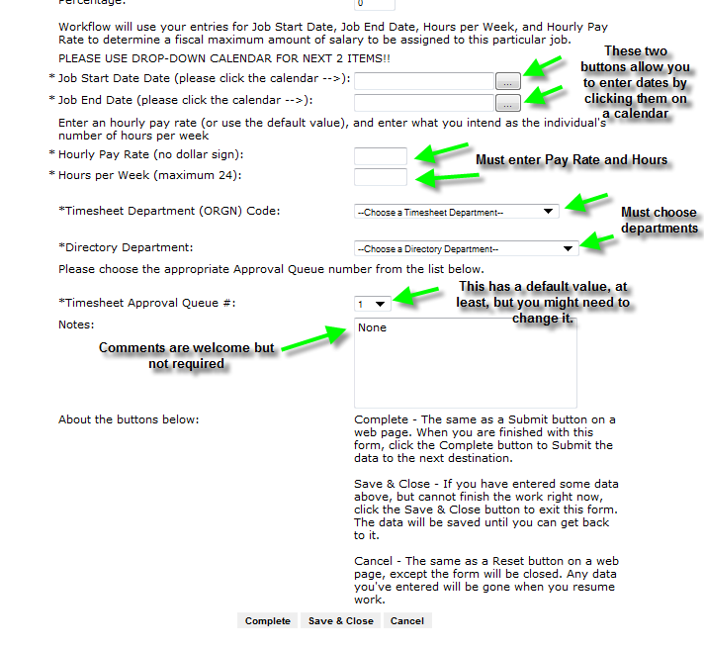

RELATED NOTES:
When supplying dates, you should always use the calendar tool by clicking where these arrows point
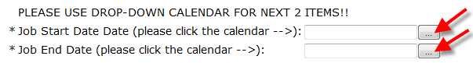

Doing so will display this:
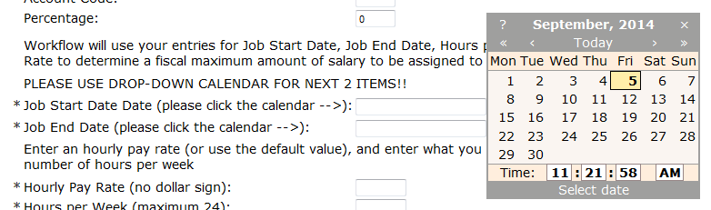

You can navigate the calendar a year at a time by clicking where the red arrows point (below), or a month at a time by clicking where the green arrows point. To choose a date, find it and click it, for example, where the blue arrow points.
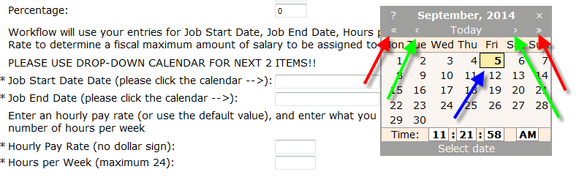
Doing so will enter dates as below. Don’t worry about the time portion of a date, it will be removed later on. Repeat this process for the Job End Date, as it is also required for a Part Time Hire.
Nearing the approach of each new school year, you should be particularly aware of the circumstance shown here:
The Job Start Date is in one fiscal year (2014) and the Job End Date is in the next (2015). Please be aware that Workflow will not allow this End Date to extend beyond August 31 for reasons I won’t go into here. You will have to submit a second Hire for the new fiscal year.

Use the drop-down lists provided to choose the appropriate Timesheet Department, Directory Department and Paycheck Distribution:
BEFORE:
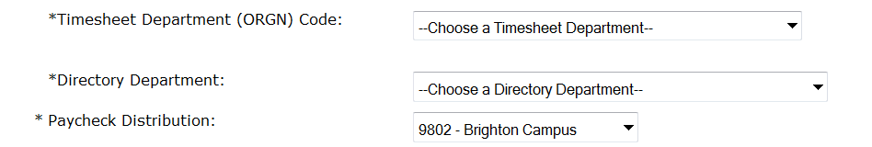
AFTER:
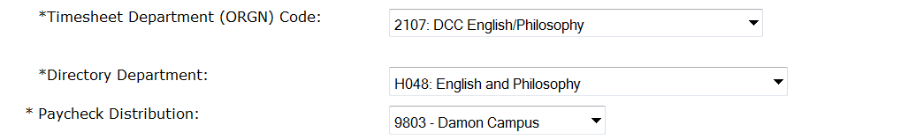

Timesheet Approval Queue should be left alone as ‘1’ unless you know otherwise.

Below is an example of a completed New Hire entry form. I know it isn’t easy to read this, but that isn’t really necessary.
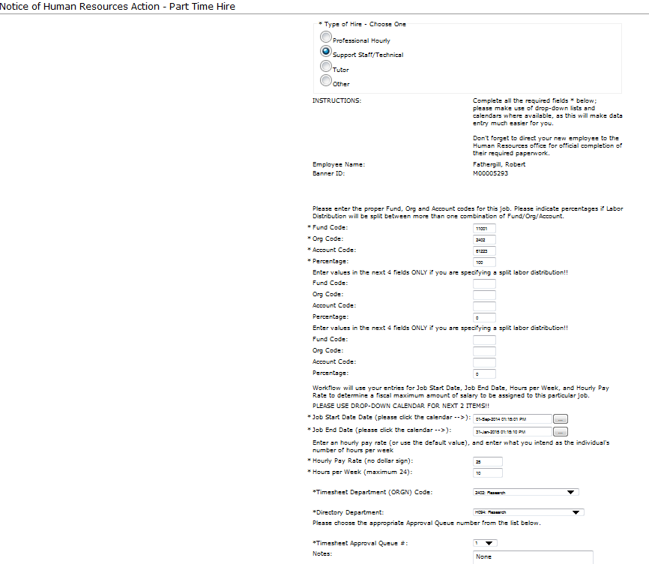
You should know that this particular person (being an existing Full-Time employee) should not really be assigned to Research as his Home Department, as is shown below.
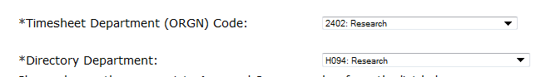
Ultimately, it would be up to the Human Resources approver to make sure that the Home Department for a hire like this remains as is (Computing Services) and does not get changed to Research. If you know that you’re hiring a Full-Time person into a Part-Time role in a different department, you can choose the person’s existing department and it will likely be correct. If you have doubts, you could call or email ahead of time, or use the Home Department doing the hiring and add a Note in the Notes box to express any concerns. Again, though, it is HR’s responsibility to review the work.

It is my intention that any form you fill out in a Workflow should have the following commentary at the bottom to explain what each of the resolution buttons is for.
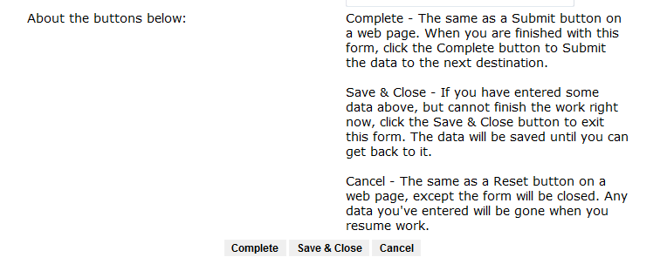

When you click Complete, the Workflow is forwarded to your Departmental Approver. He/she should see an item in My Worklist on myMCC. If you notice any Workflow behavior that does not conform to anything I’ve indicated in this document, please report it to the Help Desk or by submitting an Incident ticket from the Tech tab of myMCC.

