Substance Abuse in our Students:
Advice for Faculty


Victoria Laneri
Department of Human Services

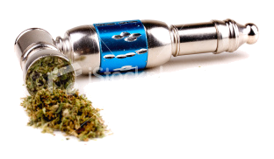



Wednesday, November 4, 2009
Noon-1:00
Community Room (4193)

