
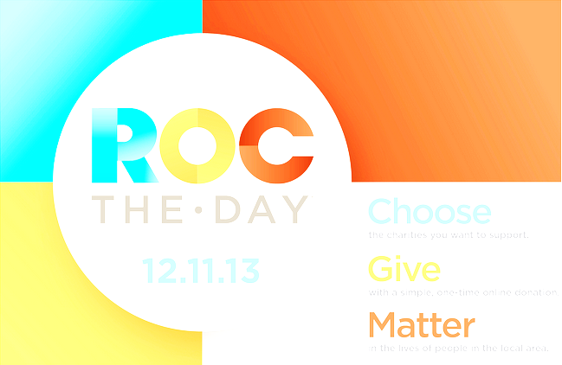

Shop the MCC Bookstore’s tomorrow at 10:00am, ROC THE DAY
and become a taster of the treats that we’re considering
for Spring
2014! Help us support students with
Scholarships through the
MCC Foundation!

Purchase
a candle
and receive a
50% off coupon
good towards the
purchase of any single item.
(excludes certain items such as electronics)

