Faculty Tips for Student E-mail

All registered MCC students automatically have an e-mail account. Student E-mail is a web-based system that uses Microsoft Outlook. A variety of distribution lists are automatically created allowing you to send messages to each individual student, class, discipline, or major.

We highly recommend that you indicate in your course information sheet and each project assignment whether you will accept assignments and questions via e-mail from your students.

This document includes resources and tips that will assist you in introducing this e-mail system to your students.

Documentation Available
Note: All of the documentation in the following list is available at the Photo ID office and the college learning centers.

- Student E-mail Quick Start Document
- Student E-mail Quick Reference business card
- On-line Help – Linked from the Student E-mail homepage (student.monroecc.edu)

Tips For Introducing Student E-Mail To Your Class
Two successful strategies for introducing this system are listed below.
- As a first assignment, require every student to send you an e-mail message.
- For a specific project, send your class a message with some “helpful tips” that is only available through the e-mail message.

Student Account Basics
This section describes the format for student account names, passwords and Internet addresses.

Student Account names are the first initial of their first name, their last name, and a three-digit number. Example: Jane Doe = jdoe005

Passwords are their 8-digit birth date.
Example: May 14, 1981 = 05141981

Use the ‘Find your account or change your password’ button to find their account name or to change their password.

Their address is accountname@student.monroecc.edu.
Example: jdoe005@student.monroecc.edu

Sending E-mail to Students
Note: If you are not familiar with the basics of Microsoft Outlook, please attend a session offered through the ETS Technical Training program. To register for a session, call the Help Desk at extension 4357. Students should not call this number; they can get assistance through the Photo ID Office at 292-2555.

The easiest method for sending messages to your students is to utilize the Address book and select individual students or particular groups (distribution lists).
To send a message to your students, follow the steps below.
- Start a new message
- Click on the “TO” button to display the Select Names dialog box.
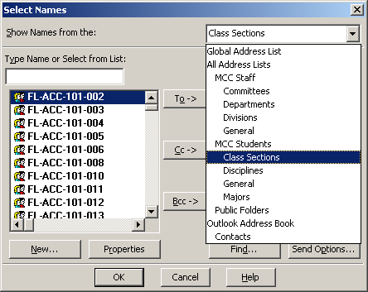
- Click on the drop box in the top right corner to display the various address books and distribution lists.
This lists each individual, class, major or discipline.
This lists all of the account categories for mail.

- Select the desired group (discussed in-depth in Distribution List section)
Note: Right click on any name and select Properties to see the members of the group. This will also display class and major information for students.
- Double Click the individual or group that you want to send the message to.
- Select OK
- Type the message and send it.

Distribution Lists
Distribution lists are used to send messages to a group of students. The student e-mail system automatically creates distribution lists for the following groups. (The format for each group is also listed.)

- Class Lists (drop/adds/withdrawals are reflected within 48 hours)
SP-CPT-215-181 (where SP is the term code)
- Discipline Lists (everyone taking at least one course in a given discipline)
SP-CPT (where SP is the term code)
- Major Lists (Every student matriculated in a particular major code)
NM01 (note, these are not term specific)

Each class and discipline list starts with a two-letter code that indicates the semester. The codes are listed below.

- FL = Fall
- IN = Intersession
- SP = Spring
- SU = Summer

Things to Know
The following list includes details that you should be aware of regarding the capabilities and limitations of the Student E-mail system.

- The Student E-mail quota is 40 MB. If they fill up this space, they will not receive messages.
- Students can send and receive attachments (Word documents, graphics, etc.).
- Students must have the proper software to open any attachments sent (e.g. faculty should only use MS Office to create documents as students won’t have access to Word Perfect in the learning centers, etc.)
- Student’s can access their e-mail anywhere in the world via student.monroecc.edu
- There are 40 student access stations in the lounges for ad-hoc student use but they can’t upload/download attachments here. They need to go to the learning centers for this.
- Faculty should give their full internet e-mail address to students for them to use when sending message to avoid any misdirection of mail (e.g. if a faculty is jsmith they should not tell the student to send mail to jsmith, as there are over 30 of them. They need to give the student their full e-mail address, which may be jsmith2@monroecc.edu.
- While the student e-mail system is backed up regularly it is not possible to restore an individual mailbox or message. We can only restore an entire system. Therefore, students should be instructed to keep backup copies of homework so they can’t use the excuse “the system lost it and they won’t recover my files”.

Student E-mail Quick Start

All registered MCC students automatically have an e-mail account. Student E-mail is a web-based system that uses Microsoft Outlook. To gain access, direct your web browser to student.monroecc.edu. Read the web pages links under E-mail Help… All of the information you will need is contained in these links. For security reasons, you should change your password. Remember to ALWAYS log off the system and close the browser when you are finished.

Enter your Username and Password here!
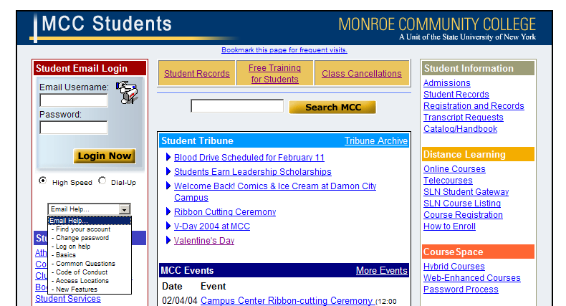

Look here for answers first!

TIPS:

- Username is the first initial of your first name, your last name, and a three-digit number.
Example: Jane Doe = jdoe005
- Password is your 8-digit birth date.
Example: May 14, 1981 = 05141981
- Your address is username@student.monroecc.edu.
Example: jdoe005@student.monroecc.edu
- You can receive mail from and send mail to other MCC students, MCC faculty and staff, as well as any e-mail address on the Internet.
NOTE: Keep your own back ups of important documents. Individual lost or deleted mail items and attachments cannot be restored from the system back up.

For Help: Visit the Student Photo ID Office, room 3-139A or call 292-2555 for assistance.

