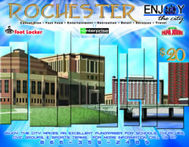 | More than $2500 in value  •  Featuring more than 100 popular local merchants  •  Sells for only $20
Participating List of Valued Merchant Partners
Rochester
Restaurants  A & W  Arby's  Azteca  BB's Pizzaria  Bears Den  Break Room, The  Burger King  Camille's  Cuisine of India  Daube's  Diggers  Dos Amigos  Double Click Coffee  El Carambas  Golden Corral  Great Harvest Bread Co  Great Steak & Potato Co  Green Mill  Hangar  HomeStyle Pizza  Inta Juice  Jaspers  Kings Crossing  Leo's Hometown Pizza  McGoon's Taxi Co  Metro  Nick-N-Willy's Pizza  Papa John's  Papa Murphy's  Perkins  Quiznos  Ranch, The  Subway  TCBY  Tinn's  Uncle G's Pizza  Winona Sandwich Co | Entertainment/Recreation  Byron Lanes  Coffee Mill Golf  Eastwood Golf Club  Lake City Golf  Mt Frontenac Golf  Northern Hills Golf  Rochester Tennis Club  Soldier's Memorial Golf | Retail/Services  C & F Video and Tanning  Dison's Cleaners  Enterprise Rent-A-Car  Foot Locker  Grease Monkey  Nature's Best Cleaners Inc  Salon 37  Stewartville Auto Center

