Study in Italy Summer 2011
Food, Wine, & Culture of Tuscany
June 4-June 28, 2011
Three ½ -week class in Florence Italy to study and experience the culture, art, and history of Florence the heart of Tuscany
Open to ALL MCC students

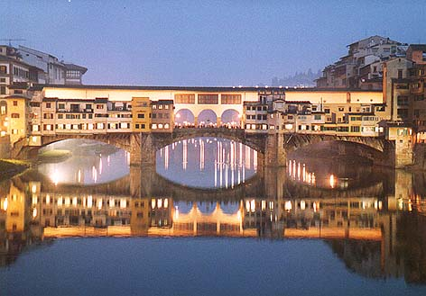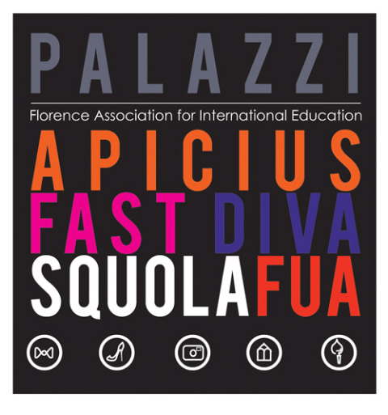

Would you like to take summer school classes and live in Florence Italy next June 2011? Would you like to visit Rome, Venice, Pisa, and Sienna? I have something that may be of an interest to you!

There will be an informational meeting in Reflections Restaurant 3-146 at 9a.m. and 4:30 on Monday & Tuesday November 29 & 30. Information will be available about the study abroad options offered within this course while in Italy.

Students can choose class options in culinary arts, baking and pastry, Italian language, photography, art history and architecture of Florence, food culture and society in Italy, pairing food and wine, professional travel and food writing, and many more.

Students will also travel to the cities of Parma, Pienza, Montepulciano & Salcheto. Do not miss this great educational opportunity.

Questions: Contact Mr. Drew Lawrence, Assistant Professor of Hospitality
585-292-2590 Room 3-140

