

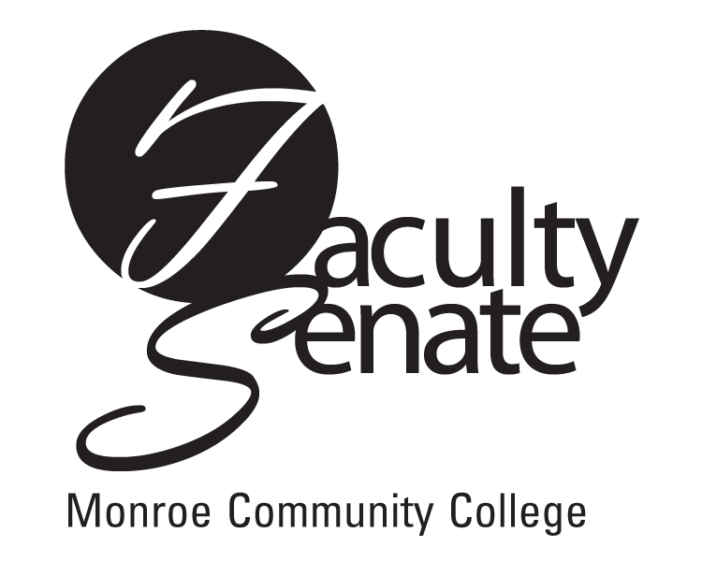
Faculty Senate Meeting Agenda
May 17, 2012 at 3:30 p.m.
Lecture Hall 8-100

- Guest Speakers:
a. Tausha Hill and Ashley Jackson, representatives from the Hillside Navigator Program
b. Terry Keys, Emerging Technology Committee
c. Christy Fogal, FCCC
d. Char Downing, Provosts Working Group on Retention & Completion

2. Announcements

3. Student Announcements

4. Approval of Minutes from April Faculty Senate Meeting

5. Action Items
a. Faculty Senate Resolution 2.1.2
b. Faculty Senate Resolution 1.1.10 – Testing and Placement Policy
c. Curriculum Proposals:
Program Revision: AAS Computer Systems Technology

6. Standing Committee Reports

7. Old Business
a. Employee Conduct Regulations

8. New Business

