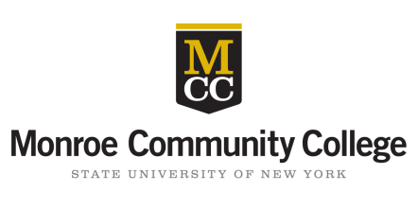*j0199465j0199465MONROE COMMUNITY COLLEGE STUDENTS:*

please pass this form to your family and friends!

Last Chance!! The deadline for submissions is April 22!

Dear Family and Friends of a Future Monroe Community College Graduate,

The Monroe Community College Foundation is pleased to offer you this special opportunity to congratulate a member of the Class of 2015 and support the college this spring. Just write a tribute to your graduating Monroe Community College student and it will be included in the MCC 2015 Commencement Keepsake. Submit your tribute with a minimum gift of $25 to secure your spot in the keepsake! Proceeds go toward the MCC Annual Fund and support scholarships and programs for future MCC students. The deadline for submissions is April 22, 2015!

*Tribute Sample:*

Sarah Johnson ’15, from Mom and Dad

*“We knew you could do it, Sarah! Congratulations on earning your liberal arts degree. We are so proud of you! Good luck at Nazareth College!”*

You may submit your dedication (maximum 40 words) online, by mail or in person. Visit the MCC Foundation’s homepage at [www.monroecc.edu](http://www.monroecc.edu)/givetomcc to make your gift of $25 (minimum) via credit card or mail in the form below using the enclosed envelope. Dedications may also be submitted at the Campus Center Desk at MCC’s Brighton Campus or at the MCC Foundation at the Damon City Campus (Room 5-032). Please print legibly or your entry may not be used. The Tribute Committee will review all comments and reserves the right to refuse and edit tributes without notice. Late entries will not be accepted.

Your Name: ­­­­­­­__________________________________________________________________ (parent, family, friend)

***Please make check payable to the***

***MCC Foundation****.*

Your Address: ­­­­­­­___________________________________________________________­____________

(street) (city) (zip code)

Your Email Address: _________________________________________________________________

Honoree: ______________________________________________________________ (MCC student)

Dedication (40 words maximum):

|  |
| --- |
|  |
|  |
|  |
|  |
|  |

**Forms must be received by April 22, 2015.** Please call the MCC Foundation at 585.262.1500 with any questions. ***Congratulations and thank you for supporting Monroe Community College.***

Monroe Community College FOUNDATION

