It’s Time for Linda to Play!

Join us on Wednesday, January 24, 2007
From 12:00 p.m. to 1:00 p.m.
In the Damon Campus TCC Room 5091
To Say Good-Bye and Celebrate
With Retiree Linda Byer

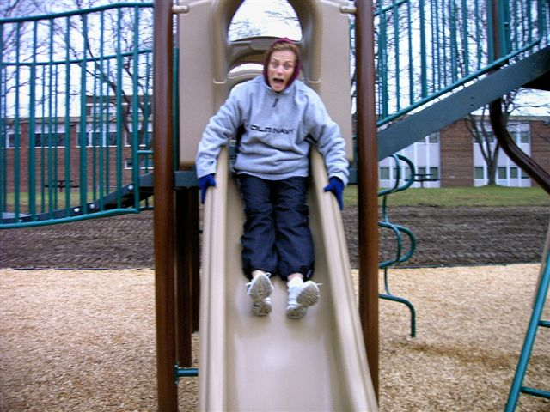

Gift collections and will be handled
by Patty Montrois x1621, Room 5058
or
Debbie Alimentato x1643, Room 5085

Congratulations Linda !!
We will miss you!

