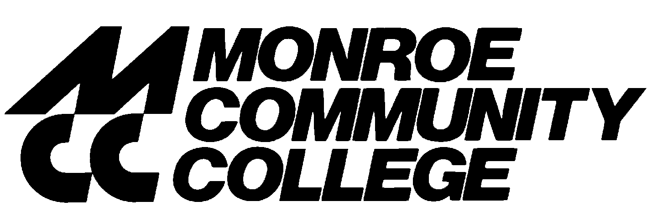

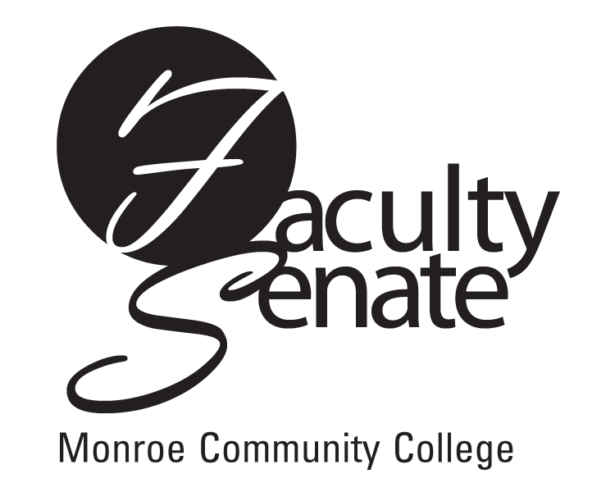 Faculty Senate Agenda
Warshof Conference Center
Empire Room
May 17, 2007
3:30 p.m.

- Guests: Diane Cecero, General Counsel – Ad Hoc Committee Report on
SCAA’s Role in Administrative Affairs
Louis Silvers, FCCC Representative – FCCC Update

- Announcements

3. Approval of Minutes from April Faculty Senate Meeting

4. Standing Committee Reports

5. Student Announcements

6. Old Business
Other

- New Business
Other

