Emergency Campus Sheltering

Save the Date!

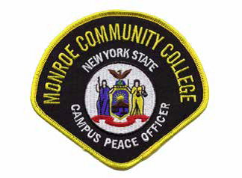

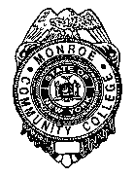
Brighton
Campus

Damon

Sponsored by the MCC Department of Public Safety

Monday, May 12th 2014
6:00pm to 7:00pm Bldg. 3 Room 209 the Empire Room

The Monroe Community College Department of Public Safety will hold an Informational Session entitled EMERGENCY CAMPUS SHELTERING on Monday, May 12th from 6:00pm to 7:00pm in 3-209 the Empire Room.
The information shared will address why campus sheltering is needed during an emergency, the definitions/information detailing lockdown procedures and what systems are used to keep you informed during in the case of an emergency.

RSVP by May 11th to Crime Prevention Specialist Chuck DiSalvo at
cdisalvo@monroecc.edu

