DISCOUNTS AVAILABLE FOR GEVA’S NEXTSTAGE PERFORMANCES OF
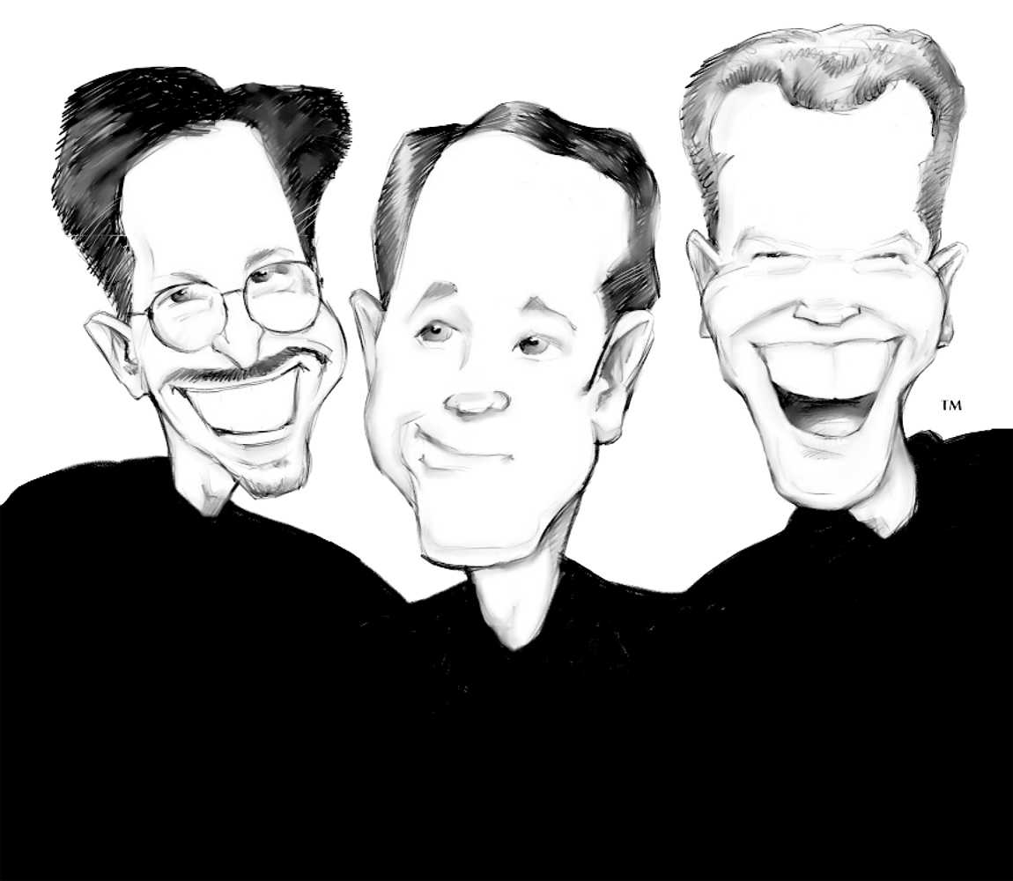
On Stage November 6 – January 11
Take 3 friends and their desperate attempt at comedy stardom. Add a gorilla, magic, shadow puppets. . . and the single most embarrassing moment ever broadcast on live television. Now that’s a recipe for robust laughs.
Triple Espresso’s highly caffeinated comedy has tickled nearly 2 million fans over the last decade. A high-energy evening of zaniness for all ages, packed with music, magic and monkey business – it’s good to the last drop! Great for the whole family!
“A triple jolt of inspired craziness...crackles with an energy and spirit of infectious fun!” Los Angeles Times
“A frothy, forget-all-your-worries evening of entertainment. You’ll laugh all the way home!” Chicago Sun-Times
“Clean laughs for the whole family!” Milwaukee Journal Sentinel
You can order specially discounted tickets for just $26.50 or $17.50 for students to a performance of Triple Espresso. For questions, or to order tickets contact Colleen Brown at 585-232-1366 ext. 3057 or e-mail to: cbrown@gevatheatre.org
30 & Under tickets for any performance are just $17.50!!
