

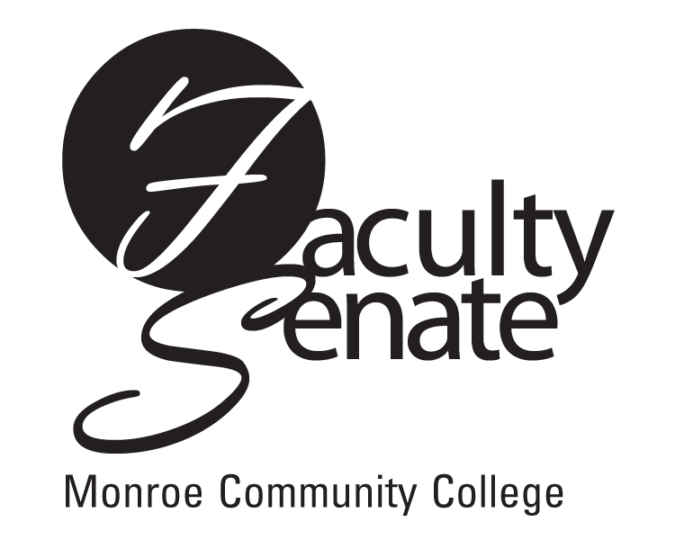
Faculty Senate Meeting Agenda
February 16, 2012 at 3:30 p.m.
Lecture Hall 8-100

1. Guests: Michael J. Gray, Student Government Association
Discussion re: Follow Me @ MCC

2. Announcements

3. Student Announcements

4. Approval of Minutes from January Faculty Senate Meeting

5. Action Items:
a) New Program - NP1F CERT Solar Thermal Technology

6. Standing Committee Reports

7. Old Business
Other

8. New Business
Other

