Food, Wine, & Culture of Tuscany
HSP 222-100 & 105
May 21-June 12, 2010
Three week culinary, cultural, art, and historical class in Florence Italy, the heart of the Tuscany Region (3 MCC elective credits)
Open to ALL MCC students, CRN 26586 & 26587

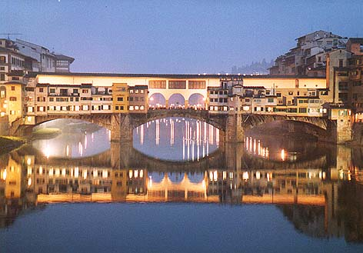

Would you like to study abroad in Florence Italy in May 2010?

Grace Jon, from Apicius International School of Hospitality in Florence Italy will be at MCC on Thursday November 5, 2009. Grace will offer an informational session in 3-157 at NOON, 2p.m., and 4:30pm. Information will be available about HSP222 and the study abroad options available for this course while in Italy.

Students can choose options in culinary arts, baking and pastry, photography, food culture and society in Italy, pairing food and wine, professional travel and food writing, art history and architecture of Florence, Italian language, and many more.

Students will also travel to the cities of Parma, Pienza, Montepulciano & Salcheto. Do not miss this great educational opportunity. Enroll now!

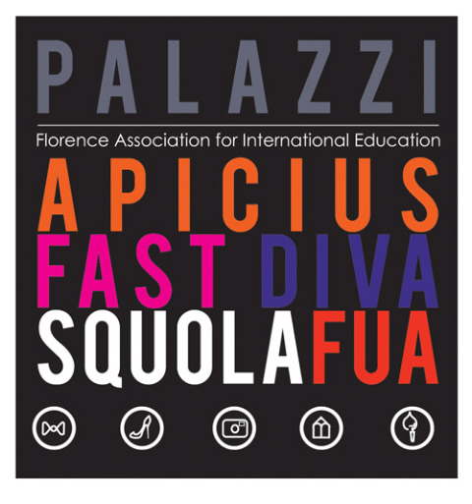

Questions: Contact Mr. Drew Lawrence, Assistant Professor of Hospitality
585-292-2590 Room 3-140

