Food, Wine, & Culture of Tuscany
HSP 222-100 & 105
May 21-June 12, 2010
Three week culinary, cultural, art, and historical class in Florence Italy, the heart of the Tuscany Region (3 MCC elective credits)
Open to ALL MCC students, register for HSP 222 CRN 26586, 26587

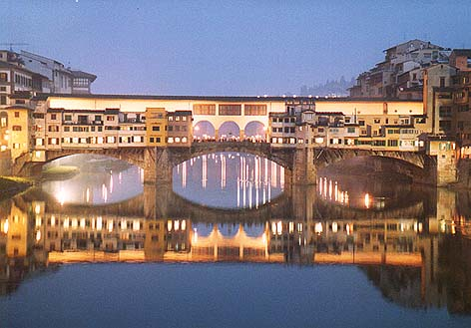
Classes in Florence

Students can choose one, 45-hour cooking classes at Apicius International School of Hospitality in Florence. A few of the topics offered are: Italian classical cakes and tarts, Everything Chocolate: From Therapy to Pleasure, Contemporary Italian Cooking, Italian regional cooking, cooking light, Tuscany and its wine, & many more. Non-hospitality students may choose classes in language, art, Food Photography I, Travel Writing, business and more. See Mr. Lawrence for the full list of classes offered.
ART

Visits to the famous art galleries of Florence: Uffizi Gallery, Academia galleries, Medici Chapels, Palazzo Pitti, Galleria Palatina:

View the most important collection of art in Italy, by Giotto, Cimabue, Botticelli, Michelangelo, Raffaello, Leonard, Tiziano and so many other great masters. Ufizzi Gallery included, additional fees may apply to all other galleries

What is included?

1 academic course of the students choice at Apicius International School of Hospitality or Florence University of Arts. The full list of courses available are listed in the hospitality department.

Airfare Rochester to –Florence & return

Accommodations is shared apartment

20 voucher meal plan

Field trips to Parma & Pienza as listed

Internet in school facilities

Worldwide medical insurance

Food, wine and fees for classes

Visit to art galleries as listed

Cultural activities listed below

*Cost: $4,939.00

FIELD TRIPS TO NORTHERN ITALY

Day Trip to northern Italy in the Po Valley: Parma - Visit the Parmigiano
Cheese Factory. Guided tour with detailed explanation of the process, marketing
strategy and consortium policies. Also included is a visit to a "Prosciutto
factory. In the afternoon visit a Traditional Balsamic Vinegar factory
part of the Consorzio Produttori di Aceto Balsamico Tradizionale di Modena.

Day Trip to Pienza, Montepulciano & Salcheto - Pienza, a little town rich in
Renaissance monuments, is known all over the world for its DOP Pecorino
cheese. Montepulciano, located on the Via Francigena, is a typical village with an
untouched medieval aspect. Its old towers, monuments and art treasures,
together with the magnificent countryside, make of this small town a “must see”
when visiting Italy. Montepulciano is also famous for a very prestigious wine (one
of the Tuscany Superwines, the Vino Nobile di Montepulciamo, the first Italian
wine to obtain the DOCG. During the trip students will taste typical foods and
wines of the region in one of the Winery of Montepulciano named Salcheto.

Cultural Activities
Guided historical and cultural tours of the city of Florence led by the faculty at the Florence University of Arts
Visit to Oltrarno area of Florence
Architectural Walking Tour
Visit to the Fresh Food Market
Visit to the Uffizi Gallery
Hill top Walk to Piazzale Michelangelo

Questions: Contact Mr. Drew Lawrence, Professor of Hospitality
585-292-2590 Room 3-140
Open to ALL students, register for HSP 222 spring 2010
http://www.deprezmeetings.com/groups/MCC_HSP_ITALY_MAY2010/index.htm

*Final cost may vary slightly based on the cost of airfare at time of booking

