Food, Wine and Culture of Tuscany
HSP 222 - Spring 2007

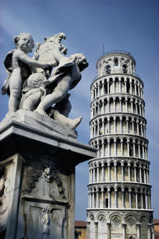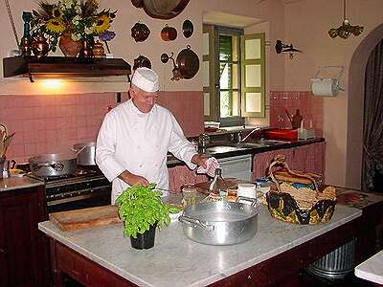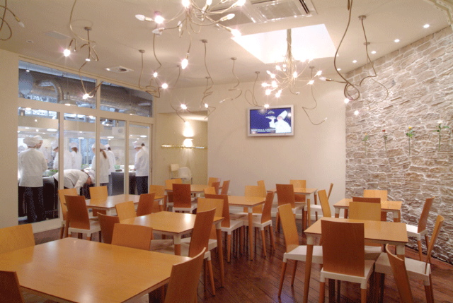

When: May 24 to June 7, 2007

Where: Tuscany area of Italy

What: Earn 3 MCC credits and experience a lifetime of culture while living and studying in Florence Italy

How: Two weeks of cooking classes with Master Chefs like the European Champion Chocolate Pastry Chef Andrea Bianchini and learning to create your own masterpieces. You will also explore the renaissance monuments; see the paintings of Michelangelo, Raffaello and Leonard plus the rich culture of Italy. We will also tour the best wine growing regions in the world producing favorites like Chianti.

Our Host:
ACIF - Apicius The Culinary Institute of Florence
Via Guelfa 85
50129 Florence – Italy
www.apicius.it

What You'll Learn and Do
Discover and taste the great food and wines of Italy! Food and Wine have always been closely linked to Italian Culture and Art!! Tuscany and Umbria are the regional focus of your trip: you’ll learn the cultural rules of food consumption, the comparison with the rules of music, dancing and poetry, the relationships between food and religion, gender, tradition, art, lifestyle. You’ll meet chefs, cookbook authors, and at the same time, you’ll experience the beautiful art works and landscape of Tuscany and Umbria!

Cost: $ 3,150 plus airfare approximate total cost $4,000.00
Includes:
- meals and activities listed in day by day schedule
- accommodation in students’ shared apartments
- activities, education, excursions, transportation
- Accommodations Singles and doubles in shared apartments
Single Supplement: $ 150

How do I enroll? Register for HSP222 Spring 2007 Integrated Studies

TENTATIVE SCHEDULE

Day 1- Depart USA
Flight to Florence

Day 2- Florence
- Transfer by Private Bus to Apartments.
- Rest and unpack.
- Orientation.
- Welcome Dinner in a Tuscan Trattoria - “A typical Florentine Menu”.

Day 3- Florence
- Your day starts with a visit to the San Lorenzo Fresh Food Market. Discover all the different products that make Tuscan Cuisine well-known all over the world exploring this unique market.
- After the market visit, you’ll walk to Apicius - The Culinary Institute of Florence.
- Lecture: “Introduction to Italian Gastronomy” followed by a tasting of all typical Tuscan products.
- Afternoon: Cooking Class “Olive Oil in Tuscan Cuisine”, with Chef Duccio Bagnoli followed by a dinner on your own creations!

Day 4- Pienza & San Gimignano
- 8:00 am departure for Pienza (Tuscany, province of Siena). Arrival around 10:30 am. Pienza, a little town rich in Renaissance monuments, is known all over the world for its DOP Pecorino Cheese. A visit of the town will be given by the accompanying professors and it will be possible to taste some pecorino cheese.
- Lunch in a small trattoria tasting typical products.
- 2:30 pm departure for San Gimignano, one of the most famous historical towns of Tuscany. San Gimignano, located about 45 minutes from Siena, is a typical village which is famous for its untouched medieval aspect. Its old towers, monuments and art treasures, together with the magnificent countryside, make this small town a “must see” when visiting Italy. We will visit the Collegiata with its beautiful 14th and 15th century frescoes. San Gimignano is also famous for a very prestigious wine, the Vernaccia di San Gimignano, the first Italian wine to obtain the DOC. Right outside of town, in San Donato, we will go to visit the cellars of one of the producers of this famous wine. There, it will be possible to taste different types of wine made in the region (Chianti Colli Senesi, Vernaccia) accompanied by some local food (prosciutto, salame, olives, olive oil…), in a regional combination.
- Return in Florence around 7:30pm.

Day 5- Florence
- After a lecture on Renaissance Florence, take an architectural walking tour of the city experiencing the beauty of Brunelleschi and Alberti’s masterpieces.
- Lunch on your own.
- Afternoon lecture with tasting: “Wines of Tuscany” with Professor Jonathan Ferace, followed by a cooking class with the chef Duccio Bagnoli on “Fresh Pasta Workshop”.
- Dinner on your own creations!!!!

Day 6- Florence
- Morning visit to the Uffizi Gallery: the most important collection of painting in Italy, housing works by Giotto, Cimabue, Botticelli, Michelangelo, Raffaello, Leonard, Tiziano and so many other great masters.
- Lunch on your own.
- Afternoon: Lecture with the famous Food Photographer Cosimo Bargellini “Food Photography Secrets”, followed by a workshop. You’ll bring home your own photographs!!!
- Pizza dinner!

Day 7- Florence
- Visit to Palazzo Pitti and Galleria Palatina.
- Lunch on your own.
- Walking tour downtown the “Oltrarno Area”.
- Dinner at the famous Restaurant “Acqua al Due”. Stefano Innocenti, the Restaurant Patron and Chef, will explain his Philosophy to you, answer your questions, and reveal the secrets of his long-term success!

Day 8- Florence
- Start your day with a lecture: “The Medici Family”, and learn about the many generations of Medici members that led Florence to be the cultural center of Europe in the Renaissance.
- Right after you’ll visit the Medici Chapels, containing sculptures by Michelangelo, as well as the monument of Lorenzo the Magnificent.
- Afternoon: Lecture “Food and Wine at the Medici Court”.
- Followed by a Cooking Class with Chef Claudia Crociani: “A Menu at the Medici Time”. Dinner on your own creations.

Day 9- Parma
- Departure by bus for Parma.
- 8:00 am arrival at the Parmigiano Cheese Factory. Guided tour with detailed explanation of the process.
- 12:00 pm lunch in Parma.
- After lunch walking Tour in the historical center.
- 3:00 pm visit to a Prosciutto.
- 5:00 pm return to Florence.

Day 10- Florence
- Gastronomic Walking Tour with tasting. Visit the many wonderful historical Food Stores, bars and café’s of Florence, tasting bites of their specialties.
- Afternoon Lecture: “Pairing Food and Wine”. How to impress your guests learning all the tricks that allow you to pair wine with your own food. Professor Diletta Frescobaldi.
- Afternoon at leisure.
- Cooking Class with Chef Duccio Bagnoli: “A Tuscan Fall Menu”. Chef Duccio will explain the menu and give you all recipes and secrets!

Day 11- Orvieto
- Deaprture for Orvieto.
- Arrival in Orvieto (Umbria) at about 10:00 am.
- Here will start our whole day dedicated to the most important products of Umbria, with the help of one of the most famous chefs of the region, Lorenzo Polegri.
- 10:30 am: Visit of the Cheese Factory Pesci in Bagnoregio, guided by a member of the staff of this farm where high quality pecorino and ricotta cheeses are made.
- 12:30pm: Dinner at the restaurant Zeppelin, located in the center of Orvieto and led by chef Lorenzo Polegri. Here you will be able to appreciate a whole meal (from appetizer to dessert) based on typical Umbrian products and cooking techniques. The menu will be accompanied by a selection of two local wines
- In the afternoon: Walking tour. Orvieto is one of the most famous cities of Central Italy, renowned for one of the most imposing cathedrals of Italy and for its wonderfully preserved middle age historical center.
- 3:30 pm: Visit of the Olive Oil Museum and of the Oil-Mill Bartolomei in Montecchio. The museum hosts an interesting selection of ancient objects and tools used in the past for the production of olive oil and for the cultivation of olive trees. It will be possible also to have an olive oil tasting. The visit will be guided by a member of the staff of the farm.
- 4:45 pm: Visit of the Cantina “Barberani” in Cerreto di Baschi, producing very high quality wines of the region. It will be possible to taste 3 great wines.
- Return to Florence.

Day 12- Florence
- Morning Lecture: Michelangelo and his time.
- Visit to the Accademia Gallery.
- Lunch at Restaurant “Il Pennello”, the oldest trattoria in Florence!
- Late afternoon: Chocolate workshop with the European Champion Chocolate/Pastry Chef Andrea Bianchini (with tasting!!!!!!!!). Learn all the secrets of tempering chocolate, of making truffles and tartes.
- Dinner on your own.

Day 13- Florence
- Free day to enjoy the city
- Farewell Dinner

Day 14- Departure

