
Multiple Sclerosis
Fundraiser
For
MCC Team

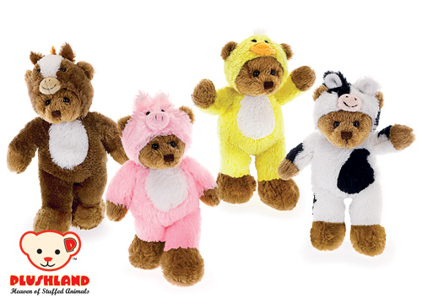
Horse
Pig
Chicky
Cow
$6.00 a piece

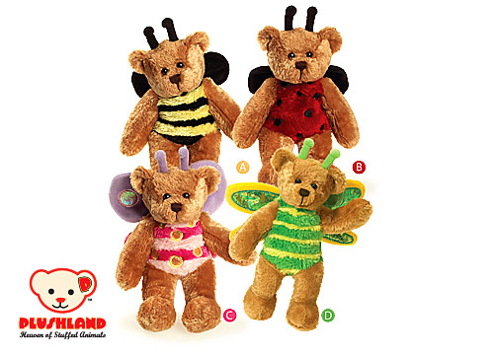
Bee
Ladybug
Butterfly
Dragonfly (green)
$6.00 a piece

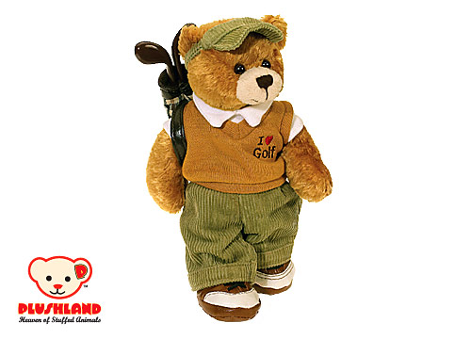
Golfer
$7 a piece

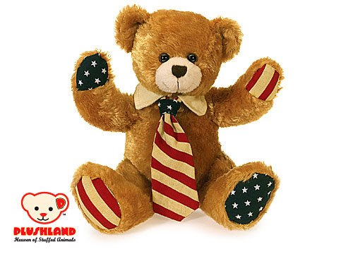
Patriotic
$6.00 a piece

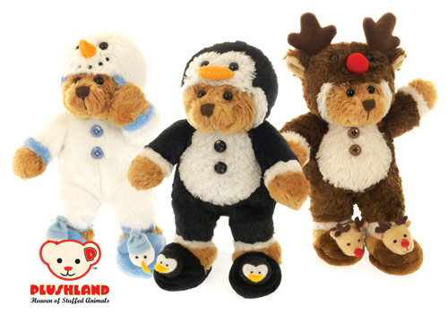
Snowman
Penguin
Reindeer
$6.00 a piece

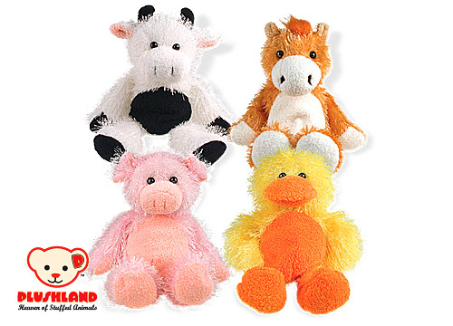
Cow
Horse
Pig
Duck
$6.00 a piece

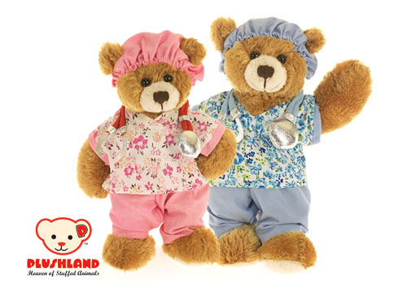
Nursing Girl
Nursing Boy
$6.00 a piece
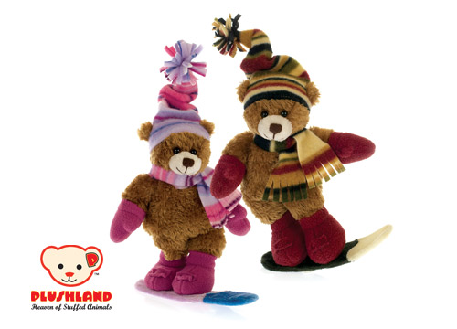
Snowboarding Girl
Snowboarding Boy

$6.00 a piece

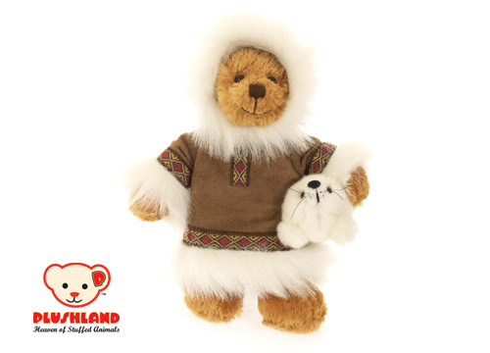
Eskimo Bear
$6.00 a piece

