

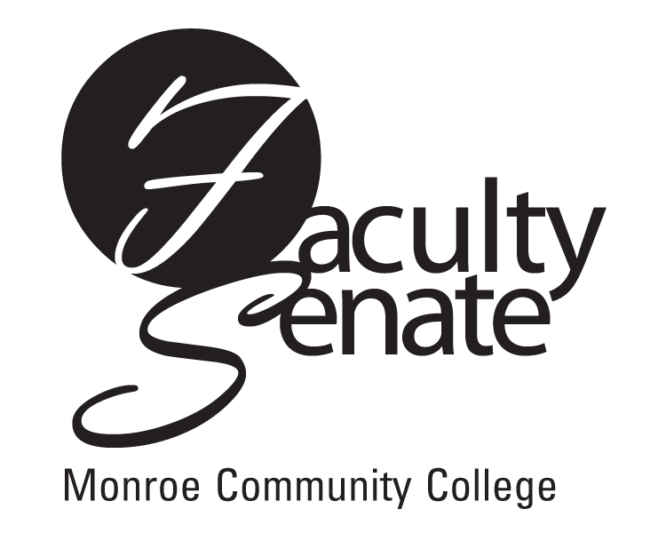 Faculty Senate Agenda
Warshof Conference Center
Empire Room
March 15, 2007
3:30 p.m.

- Guest Speaker – Beth Laidlaw – Critical Thinking Assessment Update

- Announcements

- Action Items:
Academic Policies Resolution: 1.1.10 Placement Testing
Curriculum: PD2S Electrical Apprentice Training
PR1S Health Information Technology – Medical Records
NP4F Addictions Counseling, AS

4. Approval of Minutes from February Faculty Senate Meeting

5. Standing Committee Reports

6. Student Announcements

7. Old Business
Other

- New Business
Other

