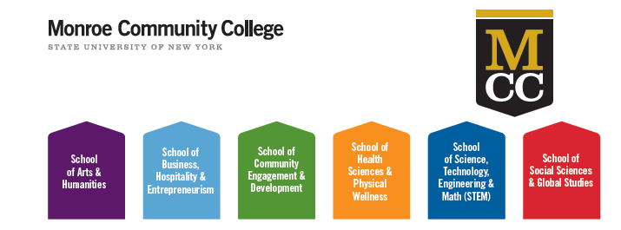
MCC Academies
Role of Faculty Liaison
The role of the liaison is to effectively communicate with the School Advising Specialist, the Student Success Network (SSN) and the faculty and staff within the designated School. One Faculty Liaison will be assigned to each School and will need to be an experienced full time faculty member (preferably tenured or with a minimum of 5 years at MCC) and will need to become well informed about the programs offered within the School. On an ongoing basis, he/she will facilitate effective communication between the Advising Specialist, faculty and SSN in order to best serve the students within the School keeping all involved up to date on current issues and/or opportunities for students enrolled in that School. The Faculty Liaison will interact regularly with the Student Support Network (SSN) which is a group of service office representatives who will assist the Schools via information sharing and functional support.
Faculty Liaison term will be a two-year appointment. This position entails partial release time each semester. There will be six hours release time in Spring 2016.
Responsibilities of Faculty Liaison might include:
- Collaborating with Advising Specialist, High Impact Practices (HIPs) Specialist, faculty, Academies Coordinator, and staff particular to the School;
- Assisting in mapping and communicating clear pathways for the School, semester by semester, including relevant General Education courses;
- Conveying best choices for HIPs courses within the programs in the School;
- Supporting the adoption of HIPs, working with faculty and staff;
- Specifying program milestones that help students stay on track;
- Supporting communication with Department Chairs and Advising Specialist to provide ongoing updates, including curricular and career information;
- Communicating with faculty about School questions/concerns/opportunities for support of student success in the School;
- Assisting with the development and implementation of School specific events;
- Supporting career development workshops/transfer options, where applicable.
Please contact Karen McCarthy, Academies Coordinator, at ext. 3190 or kmccarthy30@monroecc.edu if you have any questions or require further information regarding the position.

