

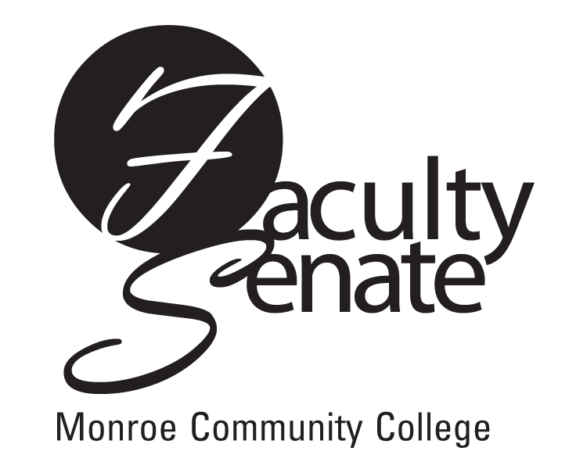
All College
Faculty Senate Meeting Agenda
June 14, 2012 at 3:30 p.m.
Warshof Conference Center - Monroe B

1. Guest Speakers:
a. President Kress – discuss Faculty Senate related issues
b. Ray Shea – update on the master plan

2. Announcements

3. Student Announcements

4. Approval of Minutes from May Faculty Senate Meeting

5. Action Items
Curriculum Proposals:
1 Program Revision: PR11S A.A.S. Entrepreneurial and Applied Business Studies
1 New Program: NP1 CERT Disability Professional: Entry Level Certificate

6. Standing Committee Reports

7. Old Business

8. New Business

