**Study in Italy Summer 2012**

**Food, Wine, & Culture of Tuscany**

**May 30-June 23, 2012**

***Three ½ -week class in Florence Italy to study and experience the culture, art, and history of Florence the heart of Tuscany***

***Open to ALL MCC students***

MCC Logo 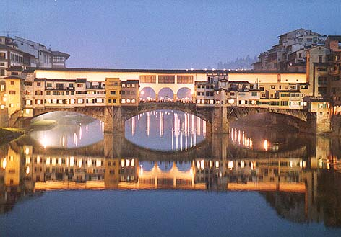 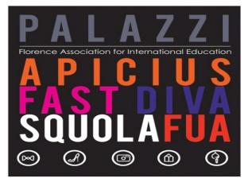

**Would you like to take summer school classes and live in Florence Italy next May & June 2012? Would you like to visit Rome, Venice, Pisa, and Sienna? I have something that may be of an interest to you!**

***There will be an informational meeting in Reflections Restaurant 3-146 at 8:30a.m. and 4:30 on Wednesday October 5. Information will be available about the study abroad options offered within this course while in Italy.***

***Students can choose class options in culinary arts, baking and pastry, Italian language, photography, art history and architecture of Florence, food culture and society in Italy, pairing food and wine, professional travel and food writing, and many more.***

***Students will also travel to the cities of Parma, Pienza, Montepulciano & Salcheto, Rome, Venice, & the Italian Riviera. Do not miss this great educational opportunity.***



Additional informational meetings: Monday Oct 10 4:30pm in 3-146, Tuesday October 11, 4:30 in 3-146, Wednesday October 12, in 3-157 Noon-1pm, and Thursday Oct.13 3:00 3-146

Questions: Contact Professor Drew Lawrence, 585-292-2590 Room 3-140 or

Professor Bartell Room 3-155 or 292-2579