MCC Network Password Changes
ETS would like to remind all faculty and staff the six month period for changing their network password has arrived. Remember a strong password is MCC’s first line of defense against unauthorized access to network resources. You will be prompted when logging on, that your password will expire in a set number of days.
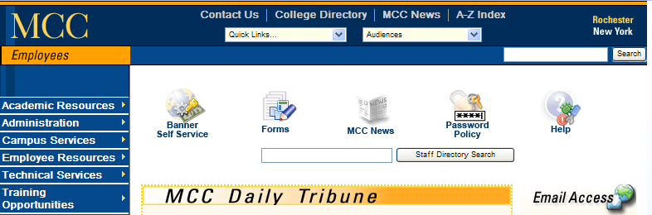

MCC’s Password Policy can be found by clicking the ‘Password Policy’ icon on the ‘Employees’ website. But here is a brief summary…
-- The new password must have 8 or more characters
-- Password cannot be reused. The system will remember the last 20 passwords.
-- Must have 3 of the following…
at least 1 upper case letter
at least 1 lower case letter
at least 1 number
at least 1 special character (#, *, =, etc.)
-- The password does not contain three or more characters from the user's account name or the previous password.

Any questions, call the Call Center x4357 when on campus, or 292-2000 x4357 when off campus.

