

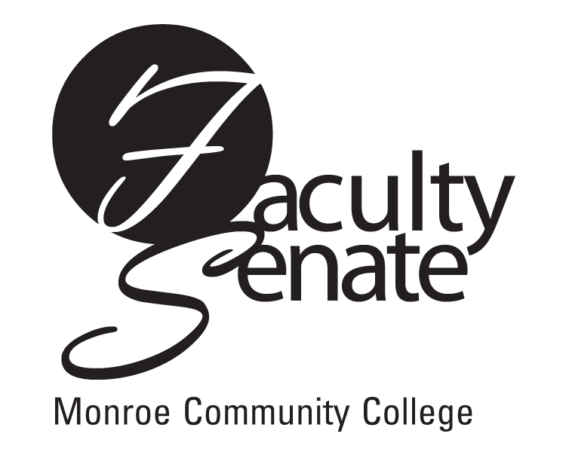
Faculty Senate Agenda
Warshof Conference Center
Empire Room
December 13, 2007
3:30 p.m.

- Guest Speaker: Margaret Murphy – FCCC Update

2. Announcements

3. Approval of Minutes from November Faculty Senate Meeting

4. Action Items:
Academic Policies: College Orientation Policy Resolution 1.1.9
Withdrawal Policy Resolution 1.1.6
Faculty Advisor System – Resolution 1.6
Professional Development: 4.1.1 through 4.4.4.4

5. Standing Committee Reports

6. Student Announcements

7. Old Business
Other

- New Business
Other

