Date: May 13, 2006
Time: 5:30PM to10:00PM

A Social To

Support Native American Youth

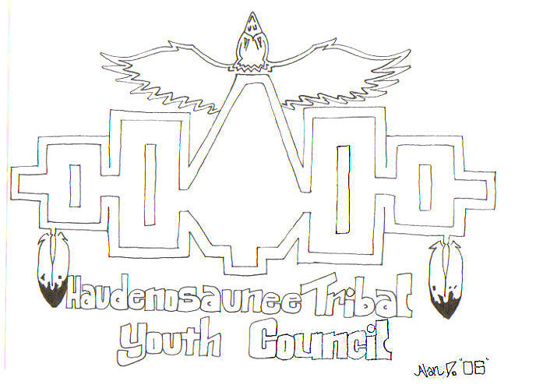
Being held at the Brookside School, 220 Idlewood Road, Brighton, NY. Off of Winton Road between Westfall Road and Interstate 590.

- Potluck Dinner from 5:30 PM to 7:00 PM.
- Please bring a dish to pass.
- Dancing begins at 7:00 PM and ends at 10:00 PM

Featuring:
- Give aways
- Bake Sale to benefit the Youth Council
- Canandaigua Treaty Committee

Hosted by the
Haudenosaunee Tribal Youth Council

CO-SPONSORED BY THE NATIVE AMERICAN CULTURAL SOCIETY CLUB

