Retirement Party!
11!

Party? We love parties!!!

For
Jackie Maggio Ryan

You mean she’s leaving?
She can’t leave us!
Oh yes I can!
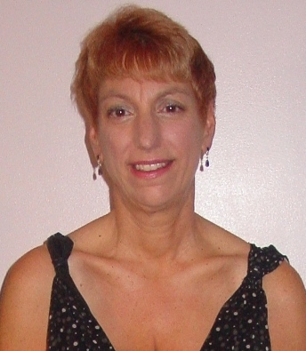
After 25 years of dedicated service to MCC, please join the Admissions Office in wishing a fond farewell to Jackie on Friday, September 29th from 2:00 to 4:00 PM in the Board Lounge.

If you would like to contribute toward a group gift for Jackie, contributions can be given to Marge McNeil (1-211, ext. 2231) or Ranae Hanson (1-309, ext. 2221).

