

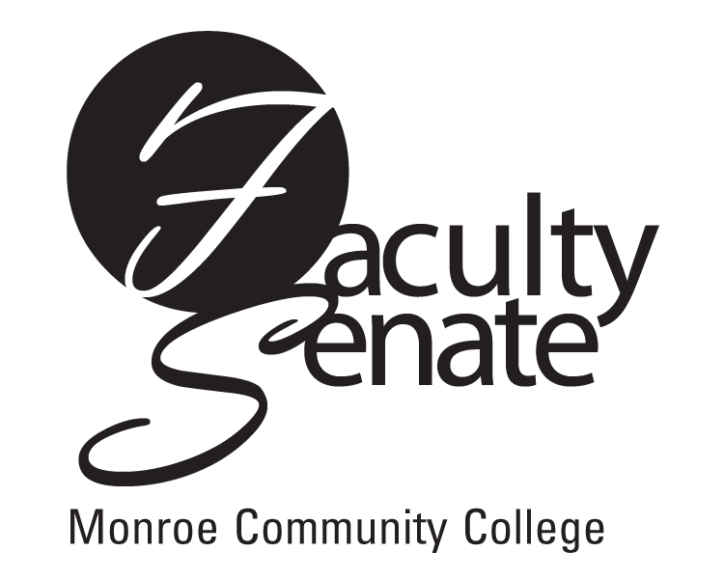
Faculty Senate Agenda
Warshof Conference Center
Empire Room
January 31, 2008
3:30 p.m.

- Announcements

2. Approval of Minutes from December Faculty Senate Meeting

3. Standing Committee Reports

4. Student Announcements

5. Old Business
Other

6. New Business
Other

