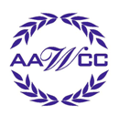 | AMERICAN ASSOCIATION FOR WOMEN IN COMMUNITY COLLEGES  Monroe Community College Chapter  __________________________________________________________________________

MEMBERSHIP Application
Fall 2016 - Spring 2017 Academic Year

PLEASE CHECK ONE OF THE FOLLOWING:
New Member | Renewal

DATE _______________________

NAME ________________________________________________________________________________

Please circle one of the following:
Administration | Faculty | Professional Staff | Support Staff | Student | Retiree

TITLE/POSITION _____________________________________________________________________

DEPARTMENT ____________________________________________________Extension___________

OFFICE LOCATION (Building and Room)_________________________________________________
❑ Brighton Campus  Damon City Campus  Applied Technologies Center  Public Safety Training Center

EMAIL ADDRESS_______________________________________________________________________

Please make the check payable to AAWCC/MCC and send to:
Sue Noonan, Academic Services (ext. 2195).
The membership fee is for the 2016-2017academic year (includes fall and spring semesters).

- Enclosed is $30 for membership (administration/faculty/professional staff/support staff) in the AAWCC-MCC Chapter and the National Chapter.
- Enclosed is $20 for retiree membership in the AAWCC-MCC Chapter and the National Chapter.

- Enclosed is $10 for student members in the AAWCC-MCC Chapter and the National Chapter.
Optional: Please select the committee(s)/event(s) you are interested in helping with this year:

Membership Professional Development Service Public Relations/Website

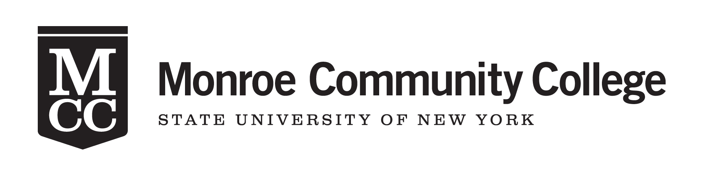
Office Use Only:
Date: _____ Check # _____
___ Membership List
___ Distribution List
___ Confirmation Sent
2016-2017 Officers  President  Julie Slate  Admissions Office  Brighton Campus  292-2224  President Elect  Brigitte Martineau  Mathematics Department  Brighton Campus  292-2967  Secretary  Krista Tyner  School of STEM  Brighton Campus  292-3199  Treasurer  Antonia Custodio  Executive Dean’s Office  Damon City Campus  262-1611  2016-2017 Chairpersons  Membership  Susan Noonan  Professional Development  Julianna Frisch  Public Relations/Web  Christine Accorso  Mary Timmons  Service  Yolanda Johnson  Courtney Sprague | AMERICAN ASSOCIATION FOR WOMEN IN COMMUNITY COLLEGES  Monroe Community College  __________________________________________________________________________  What is the American Association for Women in Community Colleges (AAWCC)?  The AAWCC was organized in 1973 and is a council member of the American Association of Community Colleges. The organization offers opportunities for women in two-year institutions by providing a forum that addresses women’s issues and acknowledges women’s achievements.  In 1993, Monroe Community College established a local chapter of AAWCC. The purposes of the organization are:  • To encourage educational program development for women in community colleges;  • To support women in leadership roles;  • To develop communications among women in community colleges;  • To promote and offer local and state workshops for women in community colleges; and  • To disseminate information on courses, programs, and services for professional women.  What are the membership requirements?  Membership at both local and national levels is open to any MCC employee, alumnus, or student employed at or enrolled in MCC or people who support the purpose of the MCC Association, Inc. Members of the AAWCC-MCC Chapter are encouraged, but by no means obligated, to participate in events and activities hosted by the chapter. Participation in planning committees is also encouraged in efforts to provide the most rewarding programs and personal development experiences to members.  Information about the benefits of national membership is available at www.aawccnatl.org.  For more information about AAWCC – MCC Chapter,  including upcoming programs and events, visit:  www.monroecc.edu/go/aawcc

